Secure messaging with zero knowledge proof and intelligent threat detection

MOHAMMAD AZRI BIN AZIZ
52215123264

Report Submitted to Fulfill the Partial Requirements
For the Bachelor of Information Technology (Hons.) in Computer System Security Universiti Kuala Lumpur

March 2026

DECLARATION

I declare that this repost is my original work and all references have been cited adequately as required by the University

Date: 12/6/2026 | Signature  Full Name:  ID Number: |   ......................................  MOHAMMAD AZRI BIN AZIZ  52215123264

APPROVAL PAGE

We have supervised and examined this report and verify that it meets the program and University’s requirements for the Bachelor in Computer System Security

Date: 12/6/2026 | Signature  Supervisor: Official Stamp: | ......................................  DR DELINA BEH MEI YIN
Date: 12/6/2026 | Signature  Accessor 1:  Official Stamp:  (Optional) | ......................................  PROF. DR. MEGAT FAREEZ AZRIL ZUHAIRI

ACKNOWLEDGEMENT
First and foremost, I express my deepest gratitude to my supervisor, Dr Delina Beh Mei Yin, for her invaluable guidance, patience, and encouragement throughout the duration of this Final Year Project. Her insight and constructive feedback were instrumental in shaping both the direction and the quality of this work.
I would also like to extend my sincere appreciation to the assessors and to the lecturers of the Bachelor of Information Technology (Hons.) in Computer System Security programme at Universiti Kuala Lumpur, whose knowledge and support provided the foundation upon which this project was built.
My thanks also go to the management and staff of NISHA SUTERA PRIMA for their willingness to take part in the user acceptance testing and for the practical insights they offered into the real-world communication needs of a small enterprise.
Finally, I am profoundly grateful to my family and friends for their unwavering moral support, understanding, and motivation throughout my studies. This accomplishment would not have been possible without them.

Table Of Content

CHAPTER 1 12
INTRODUCTION 12
1.1 Introduction 13
1.2 Background of the Study 13
1.3 Problem Statement 15
1.4 Objectives 16
1.5 Project Scope 18
1.6 Significant of The Projects 20
1.7 Organization of the Report 22
CHAPTER 2 24
LITERATURE REVIEW 24
2.1 Introduction 25
2.2 Overview of Secure Enterprise Messaging 25
2.3 Zero Knowledge Proofs (Authentication) 26
2.3.1 Privacy Preserving Authentication 26
2.3.2 Feasibility on Resource-Constrained Devices 27
2.3.3 Application in Identity and Data Integrity 27
2.4 End-to-End Encryption (E2EE) Protocols 28
2.4.1 Vulnerabilities in Authentication Ceremonies 29
2.4.2 The Insider Threat Landscape 29
2.4.3 Architecture and Scalability 30
2.5 On-Device AI Anomaly Detection 31
2.5.1 The Shift to Edge Computing 31
2.5.2 Mobile Optimization Techniques 31
2.6 Summary and Research Gap 32
2.7 Conclusion 33
CHAPTER 3 34
METHODOLOGY 34
3.1 Introduction 34
3.2 Overview of Software Development Models 34
3.2.1 Waterfall Model 35
3.2.2 Agile Model 36
3.2.3 Rapid Application Development (RAD) 37
3.3 Proposed Methodology 38
Justification for Choosing RAD 38
3.4 Phases of Development 40
3.4.1 Phase 1: Requirements Planning 40
3.4.2 Phase 2: User Design 40
3.4.3 Phase 3: Construction 46
3.4.4 Phase 4: Cutover 47
Integration Testing: 47
Security Audits: 47
User Acceptance Testing (UAT): 47
3.5 System Requirements 48
3.5.1 Hardware Requirements 48
3.5.2 Software Requirements 49
3.5.3 Budget and Costing 50
3.6 Project Planning 51
Gantt Chart Link: Excel_File_Link 51
3.7 Chapter Summary 52
CHAPTER 4 53
SYSTEM DEVELOPMENT 53
4.1 Introduction 53
4.2 Development Environment and Tools 54
4.2.1 Hardware and Operating System 54
4.2.2 Integrated Development Environments and Tooling 55
4.2.3 Frameworks, Languages and Runtimes 55
4.2.4 Software Dependencies 56
4.3 System Architecture as Implemented 59
4.4 Installation, Setup and Configuration 62
4.4.1 Backend Server Setup 62
4.4.2 Zero-Knowledge Circuit Compilation and Trusted Setup 63
4.4.3 Web Portal Setup 63
4.4.4 Mobile Application Setup 63
4.4.5 Machine-Learning Pipeline Setup 64
4.5 Implementation of the Core Security Modules 64
4.5.1 Module A: Zero-Knowledge Proof Authentication 64
4.5.2 Module B: End-to-End Encrypted Messaging 68
4.5.3 Module C: On-Device AI Threat Detection 70
4.6 User Interface and Experience Design 75
4.7 System Integration 76
4.8 Source-Code Management and Version Evolution 79
4.9 Deployment Environment 80
4.10 Chapter Summary 81
CHAPTER 5 82
RESULT AND DISCUSSION 82
5.1 Introduction 82
5.2 Testing Methodology and Environment 83
5.3 Functional Testing 84
5.4 Security Testing 85
5.4.1 Confidentiality 85
5.4.2 Integrity 86
5.4.3 Availability 87
5.4.4 Authentication, Authorisation and Accounting (AAA) 88
5.5 Vulnerability and Static Scanning 89
5.6 Machine-Learning Detection Performance 89
5.7 Performance and Latency 94
5.8 User Acceptance Testing 95
5.9 Discussion 97
5.10 Chapter Summary 98
CHAPTER 6 99
CONCLUSIONS AND RECOMMENDATIONS 99
6.1 Introduction 99
6.2 Achievement of the Project Objectives 99
6.3 Conclusion of the Project 101
6.4 Limitations of the Project 102
6.5 Recommendations for Future Work 103
6.6 Commercialization 104
6.7 Concluding Remarks 105
REFERENCES 106

LIST OF FIGURES
Figure 2.3.1.1: Zero-Knowledge Proof Sequence Diagram 26
Figure 3.2.1.1: Diagram Waterfall Model 35
Figure 3.2.2.1: Diagram Agile Model 36
Figure 3.2.3.1: Diagram Rapid Application Development (RAD) Model 37
Figure 3.4.2.1: SentriZK System Architecture 41
Figure 3.4.2.2: SentriZK Sequence Diagram 42
Figure 3.4.2.3: SentriZK Flow Chart 43
Figure 3.4.2.4: SentriZK Use Case Diagram 44
Figure 3.4.2.5: SentriZK Misuse Case Diagram 45
Figure 3.6.1: Project Gantt Chart Summary 51
Figure 4.1: SentriZK Full System Architecture (as implemented) 60
Figure 4.2: Component Diagram of the Flutter Mobile Application 61
Figure 4.3: Zero-Knowledge Registration Flow 66
Figure 4.4: Zero-Knowledge Login Flow with Nonce-Bound Session 67
Figure 4.5: Signal Protocol End-to-End Encrypted Messaging 69
Figure 4.6: On-Device TensorFlow Lite Threat-Detection Pipeline 72
Figure 4.7: URL Phishing-Detection Architecture 74
Figure 4.8: Mobile Application User Interface (representative screens) 75
Figure 4.9: Web-Based Administrator Panel 76
Figure 4.10: Session Lifecycle and Security 78
Figure 4.11: Deployment and Infrastructure Architecture 80
Figure 5.1: Per-Class Classification Metrics (Bi-LSTM vs Conv1D) 90
Figure 5.2: Confusion Matrices on the 1,148-Message Validation Set 91
Figure 5.3: Model Performance Comparison Against the 90% Target 91
Figure 5.4: Predicted Threat-Score Distribution by True Class (Conv1D) 92
Figure 5.5: Receiver Operating Characteristic (ROC) Curves 93
Figure 5.6: User Acceptance Testing - Mean Score per Question (n = 5) 96

LIST OF TABLES
Table 3.5.3.1: Project Cost Breakdown 50
Table 4.1: Development and Test Hardware 54
Table 4.2: Core Framework of Each System Tier 55
Table 4.3: Principal Backend Dependencies 56
Table 4.4: Principal Web Portal Dependencies 57
Table 4.5: Principal Mobile Application Dependencies 58
Table 4.6: Backend Environment Configuration 62
Table 4.7: Zero-Knowledge Circuit Parameters 65
Table 4.8: On-Device Threat-Detection Model 71
Table 4.9: Iterative Version Evolution of the Prototype 79
Table 5.1: Overview of Testing Types 83
Table 5.2: Functional Test Cases and Results 84
Table 5.3: Confidentiality Test Results 86
Table 5.4: Integrity Test Results 87
Table 5.5: Availability Test Results 88
Table 5.6: AAA Model Mapped to Implemented Controls 88
Table 5.7: Dependency Vulnerability Scan (npm audit) 89
Table 5.8: Model Performance Comparison 90
Table 5.9: Machine-Learning Detection Functional Tests 94
Table 5.10: Indicative Performance Measurements 94
Table 5.11: User Acceptance Questionnaire and Mean Results 95
Table 5.12: Individual Participant Responses (n = 5) 96
Table 6.1: Achievement of the Project Objectives 101
Table 6.2: Limitations and Corresponding Recommendations 103

ABSTRACT
The security of internal messaging platforms presents a persistent challenge for small and medium enterprises (SMEs), which rely on collaboration tools that store user credentials on centralised servers and lose visibility of threats once messages are encrypted. This dissertation presents SentriZK, a secure internal chat application that resolves the conflict between privacy and security by integrating three technologies: Zero-Knowledge Proof (ZKP) authentication, end-to-end encryption (E2EE), and on-device artificial intelligence (AI) threat detection. The system was developed using the Rapid Application Development methodology and comprises a Flutter mobile application, a Next.js web portal, a Node.js backend, and a Python machine-learning pipeline. Authentication is performed without transmitting passwords, using Groth16 zk-SNARK circuits whose proofs are generated through a single-use Mobile Access Token bridge, so that the server stores only mathematical commitments. Messages are protected with the Signal Protocol, providing forward secrecy, while a quantised convolutional neural network embedded in the application scans messages for phishing and social-engineering threats entirely on the device, preserving privacy. The completed prototype was evaluated through functional, security, performance, and user-acceptance testing. All functional test cases passed, and the system withstood nineteen automated and sixteen manual adversarial security tests organised around the Confidentiality-Integrity-Availability triad, defending against credential theft, proof forgery, replay, session hijacking, reverse engineering, traffic interception, and denial-of-service attacks. The on-device detection model achieved an accuracy of 89.2 per cent and an area under the ROC curve of 96.2 per cent while running in a model of under one megabyte. Cryptographic operations were shown to be feasible on consumer hardware, and the system achieved an overall user-acceptance rating of 4.32 out of 5. The results demonstrate that an SME does not have to choose between protecting employee privacy and detecting threats: both can be achieved simultaneously on affordable, self-hosted infrastructure. The project contributes a working blueprint for privacy-preserving, intelligent, and low-cost secure messaging, and identifies clear directions for future work including behavioural anomaly detection and post-quantum cryptography.

CHAPTER 1

INTRODUCTION

1.1 Introduction

Security of private messaging apps poses a major hurdle in today's workplace talk. Firms, particularly smaller ones lean on software such as Slack or Teams to stay connected throughout the day. Yet those services usually save login details on shared digital hubs, turning them into easy spots for hackers to strike. When a main database gets compromised, intruders might take password hashes or access keys, letting them pretend to be workers while gaining entry to private information. Instead of just forcing passwords, hackers now often steal entire sessions, just like we saw in big leaks lately.

Nowadays, inside risks along with malware spreading become more common issues. Even though E2EE guards data during transport, security experts lose visibility. Scanners used on regular servers fail because they cannot access contents inside encrypted chats. That missing insight leaves defenses weakened. So someone on the inside, either acting badly or pressured, might pass dirty messages or downloads and those go right past what the server checks for.

To address these issues, this project introduces a secure communication framework. It combines Zero-Knowledge Proofs (ZKP) to authenticate users without sending passwords over the network, and on-device Artificial Intelligence (AI) to detect threats locally on the user's phone. This is the direction that this project is going. Its goal is to create a system that eliminates credential theft risks by verifying identity mathematically and uses lightweight AI to find anomalies without breaking user privacy. This project mainly looks at the integration of the Groth16 ZKP protocol and TensorFlow Lite models for identifying behavioral anomalies in a mobile environment.

1.2 Background of the Study

In messaging setups, logging in gets explored through various means. Passwords often sit in one main storage spot, hashed and salted for safety. Yet findings point out flaws that central spot can crash everything if it fails. Session tokens in wrong hands might slip past Multi-Factor Authentication, letting attackers see private messages inside companies (Threat modeling for enterprise secure messaging applications, 2025). A fresh look at security could start with Zero-Knowledge Proofs. Backed by research from 2024 into how logins get verified, using zk-SNARKs allows checks on who someone is without moving any personal details around. Rather than posting secrets out loud, a person might prove they know a password by demonstrating it without revealing the actual code to the server.

Anomaly detection in encrypted environments is also getting more attention these days. A lot of writing has been done on using Machine Learning (ML) to find threats. A systematic review of anomaly detection using machine and deep learning techniques (2022) highlights that Deep Learning outperforms standard ML on high-dimensional data but often requires significant bandwidth and processing power. Usually, this processing happens on a cloud server, which is not possible when messages are end-to-end encrypted.

Some research looks at things more generally by moving detection to the device’s edge or local level. Take AI-powered smishing spotting on Android phones - recent efforts like Tiny BERT (2025) and the PHILDER setup (2025) for low-end gadgets - they prove compact AI setups handle tasks well. Accuracy hits 96% or higher right there on the phone. That means less delay plus better control over personal data. Running things locally means stronger privacy and faster results. Still, nearly all current fixes aim at spotting fake texts or suspicious links instead of watching user actions live inside secure message chats.

Implications for this project:
The background shows that while ZKP and Edge AI are powerful individual technologies, they are rarely combined in SME messaging apps. Many existing systems either prioritize security (encryption) but lose visibility on threats or prioritize threat detection (server scanning) but compromise privacy. This project aims to build a clear, reproducible, secure messaging pipeline using the Groth16 protocol for auth and on-device TensorFlow Lite for detection, following the Rapid Application Development (RAD) methodology.

1.3 Problem Statement

Although many platforms use encryption and MFA, several important problems remain when we look at securing internal communications for SMEs. These problems are:

- Centralized credential storage acts as a single point of failure.
Some companies use systems that hold hashed login details locally. Take what happened with Slack in 2023 - hackers used stolen tokens or exposed info inside company databases, letting them read work chats. Stored secrets, even with extra login steps, leave gaps when breaches occur (Threat modeling for enterprise secure messaging applications, 2025). This project tackles that issue using Zero-Knowledge Proof authentication - the server keeps no passwords, just math-based commitments that leave intruders empty-handed

- End-to-End Encryption creates a "blind spot" for threat detection.
Even though scrambling messages shields them from outsiders, it also hides what servers can check for danger. Take 2025, attackers slipped harmful code through Discord invite links buried in everyday talk (AI-driven smishing detection in Android devices, 2025). Right now, there’s no live system spotting hidden risks or odd behavior since the machine never reads the actual words being sent. Local processing now handles detection, shifting tasks to the user's device through encrypted AI processing. Risk assessment occurs where data resides, skipping central hubs. Behavior analysis happens privately, maintaining control over sensitive information. Decryption is not required for insights, since evaluation takes place offline. Security stays intact because no cleartext data travels outside the endpoint. Performance improves since network traffic drops out of the loop. The shift keeps confidentiality without relying on optional trust platforms.

1.4 Objectives

The aim of this project is to develop a secure internal chat application for SMEs that integrates Zero-Knowledge Proof (ZKP) authentication and on-device AI anomaly detection to eliminate credential theft and detect insider threats without compromising user privacy.

The project is guided by the following objectives:
1. To study existing authentication and anomaly detection methods in internal messaging systems and identify their security limitations.
This involves investigating the security architecture of current End-to-End Encrypted (E2EE) platforms to understand why manual authentication ceremonies fail and how centralized credential storage creates single points of failure. Detailed research will be conducted on the mathematics of the Groth16 zk-SNARK protocol to understand how it allows for password-less verification. Furthermore, the study will analyze different Machine Learning architectures, specifically comparing Cloud-based detection versus Edge AI (On-Device) methods. This is crucial to identify how heavy models like Isolation Forests can be optimized for mobile processors (TensorFlow Lite) to detect behavioral anomalies such as phishing links or unusual login times without sending private data to a central server.

2. To develop a secure internal chat application integrating Zero-Knowledge Proof authentication and on-device AI anomaly detection.
This means building a "Privacy-First" ecosystem through engineering, done via Rapid Application Development (RAD). Writing happens alongside custom cryptographic circuits built with Circom - proof creation runs on clients’ devices. Because of this setup, no passwords exit the user’s gadget during login attempts. At the same time, another task unfolds: teaching a TensorFlow Lite model until it fits within a Flutter mobile app. That model runs under its own logic, baked into the app’s structure. In operation, the system picks up user input as it happens, breaking down message details to work out a risk level on the fly - all without touching the AES-256 lock that guards data exchange. Real-time processing feeds into how tokens are split apart, keeping things local yet accurate.

3. To test the System Functionality and Security Level effectiveness.
This involves conducting a series of performance and security tests to benchmark the system against standard metrics. The testing phase will focus on three key areas: Authentication Latency, measuring the time required to generate and verify ZKP proofs on standard mobile hardware; Detection Accuracy, using datasets of known social engineering attacks to verify if the on-device AI correctly flags malicious content with minimal false positives; and Privacy Auditing, ensuring that even during a simulated server breach, no usable credentials or plaintext messages can be extracted from the database.

1.5 Project Scope

This work focuses on building a secure communication solution suited for workplace use. Its coverage includes several main concerns.

Target users: People using this project fall into employees and high level decision makers working in Small and Medium Enterprises where private business information is handled often. Roles here include finance staff, human resources leaders, system administrators responsible for digital infrastructure inside companies all needing tight data protection. Security becomes easier when tools work well without demanding advanced tech knowledge. Because team members bring different skill levels, the goal sits just beneath surface: safety must not slow daily work or make it harder to use.

Functions and features of the system: At its center, the tool handles key security tasks while protecting personal details. It begins with Zero-Knowledge Proof authentication users prove who they are without sending their password across networks. Instead of storing or holding login data, the process uses mathematical checks run entirely offline. Built around Groth16 methodology, these local computations create evidence the system can verify. Should a breach occur on the hosted side, attackers gain nothing from it. Proof exists, but nothing identifiable gets recorded (Groth16, client-side proof generation).

On top of locked-down access, the tool runs local AI checks for odd behavior. Rather than forwarding data to a remote server, it uses a built in TensorFlow Lite framework to examine what users type in and messages they send, moment by moment. Watched signs include odd URLs, mismatched typing rhythms, or times when signing in feels off. Decisions happen right there, not after sending signals overseas. Looking closely at these elements where they’re used helps spot risky behavior like hackers pretending to be coworkers even before data gets locked up.

User interface and experience: One way the system works is by using a Flutter-based interface. Because of this, people find it straightforward to move around inside the app. Handling encryption keys becomes simpler too. Security notifications stay within reach without requiring complex tech understanding. A live threat signal shows up clearly on screen. When danger approaches, a red banner appears right away. The artificial intelligence flags risky behavior just in time. This visual cue helps users choose wisely when deciding to share private information.

Implementation platform and development environment: Development environment and tools The project will be developed primarily for Android mobile devices, utilizing Visual Studio Code and Android Studio as the primary Integrated Development Environments (IDEs). Built on Node.js, the backend verification service manages ZKP proofs circom handles cryptographic circuit creation. Performance adjustments focus on mobile hardware, particularly processors, to maintain smooth operation without excessive power use. Math-intensive tasks like AI and zero knowledge proofs stay efficient on everyday phones.

Security elements in the system: Security is integrated through Zero Knowledge Proof authentication and local artificial intelligence processing. Zero Knowledge Proofs ensure identity verification without transmitting or storing passwords, while Groth16 client-side proof generation prevents sensitive data exposure even during server-side breaches. Local AI analysis using TensorFlow Lite allows real-time detection of abnormal behavior without sending user data to external servers.

1.6 Significant of The Projects

The significance of this study comes from the urgent need to solve the conflict between user privacy and system security. In the current digital landscape, Small and Medium Enterprises (SMEs) are often forced to choose either they encrypt everything and lose the ability to spot insider threats, or they monitor everything and violate user privacy. This project is significant because it proposes a third option, using mathematics and local AI to achieve both at the same time.

This study contributes to the field and benefits stakeholders in three specific ways:
1. Eliminates the risk of credential theft. One of the biggest issues in cybersecurity today is that servers hold too much sensitive data. If a database is hacked, passwords even hashed ones are at risk. This project is significant because it proves that authentication can happen without the server ever knowing the user's password. By implementing Zero-Knowledge Proofs (ZKP), this study provides a working blueprint for "password less" security. It shows developers that it is possible to verify a user’s identity mathematically, meaning that even if the server is breached, there are no credentials for attackers to steal.

2. Demonstrates privacy-preserving threat detection. Currently, most "insider threat" detection tools require reading the messages employees send, which creates privacy concerns and compliance issues with laws like the PDPA or GDPR. This project is significant because it shifts the detection logic to the "Edge" (the user's phone). It demonstrates to business owners and security officers that they can detect malicious behavior like someone sending phishing links without ever decrypting private chat. This helps organizations maintain strict security standards while respecting the privacy rights of their staff.

3. Benchmarks High-Grade Security on Resource-Limited Hardware. There is a common belief that heavy cryptographic protocols like zk-SNARKs and AI models are too slow for standard mobile phones. This study challenges that assumption. By optimizing these technologies to run on a standard Android device, this project provides valuable data to the academic community regarding the limits of mobile hardware. It serves as a benchmark for future researchers, proving that consumer grade devices are now powerful enough to handle enterprise-grade encryption and AI inference simultaneously without ruining the user experience.

1.7 Organization of the Report

This dissertation is structured into five chapters that logically detail the research, design, development, and evaluation of the SentriZK project. The following chapters describe the progression from theoretical research to the final working system:
- Chapter 2 Literature Review: This chapter sets up the thinking behind the work. It looks at past studies across three areas: Zero-Knowledge Proofs, how messages stay locked down, and AI that runs on devices. Because today's main messaging platforms collect too much data, the section shows where they fall short. One major gap stands out - keeping watch for security risks while still protecting personal privacy. That open need is exactly what the effort sets out to tackle.

- Chapter 3 Methodology: This chapter explains how the main goal of the project was achieved through a clear method. Instead of just listing tools, it shows why RAD was chosen for building the system. You will find drawings that map out how parts connect within the tech framework. Hidden details about privacy protection appear alongside schematics showing data flow paths. Because this lays down practical steps, others can replicate key functions safely. What matters is now someone else needs only refer to these pages to replicate exact builds without guessing.

- Chapter 4 System Development: This chapter shows what happened when the software was made. First comes setup, where choices were made and tools added via plugins. After that, stages unfold - bits of code appear along with early functions - for Version 1, then adjustments pile into Version 2. Each change builds on the last, revealing progress through doing.

- Chapter 5 Result and Findings: This chapter looks at whether the system really functions as intended. Various testing methods come into play checking how it works, ensuring security holds up, plus making sure real users agree it meets the needs. Each test runs certain scenarios by design; outcomes appear clearly here, showing the system is both safe and on track with what was planned.

- Chapter 6 Conclusions: This last section ties everything together. Thoughts gather here about what stood out during the journey. How things unfolded gets examined closely. Each goal laid out in Chapter 1 now shows clear signs of being met. The reasons behind certain outcomes are worth noting take center stage. It also recognizes what the existing setup can’t do well. Future growth plans are laid out clearly here too.

CHAPTER 2

LITERATURE REVIEW

2.1 Introduction

This chapter reviews the existing body of knowledge regarding secure communication systems, cryptographic authentication, and mobile anomaly detection. A fresh look at today’s tools begins here sorting them into three areas tied directly to what the project runs on. Each part holds weight because it connects straight to how things work together. What works well shows up just as clearly as what falls short. This split helps make sense of where effort should go next without losing sight of the bigger picture.

- Zero Knowledge Proofs (Authentication): An evaluation of privacy-preserving protocols that eliminate the need for password transmission.
- End-to-End Encryption (E2EE) Protocols: An analysis of current secure messaging standards, focusing on authentication vulnerabilities, scalability, and the detection of insider threats.
- On-Device AI Anomaly Detection: A review of machine learning techniques optimized for resource-constrained mobile environments to detect malicious behavior locally.

The chapter concludes by synthesizing these domains to identify specific research gaps, highlighting the lack of integrated solutions in the current landscape.

2.2 Overview of Secure Enterprise Messaging

Looking at tech tools first doesn’t mean we skip what secure messaging in businesses really means. These tools help teams talk inside work environments keeping messages private, trustworthy, and always reachable. Not just any setup fits large organizations; each one built right tackles espionage risks head on. Rules like legal mandates shape how these systems behave across company networks.

What marks today’s protected messaging? It’s called End-to-End Encryption. Keys sit entirely on the user’s phone or tablet. Data gets locked while sending, stays locked during transit. Only unlocks when it reaches the other person. Nobody in between not carriers, not servers sees the real message. Even though E2EE strongly guards against outside eavesdropping, research shows it struggles with checking who uses the system and spotting risks from within.

2.3 Zero Knowledge Proofs (Authentication)

To address the inherent risks of transmitting passwords or credentials over a network, researchers have extensively investigated Zero Knowledge Proofs (ZKPs). These cryptographic protocols allow a "prover" to demonstrate knowledge of a secret to a "verifier" without ever revealing the secret itself.

2.3.1 Privacy Preserving Authentication
One big reason people are moving away from old-style logins? They want to leave out hidden keys nobody should hold. Take a look at what Bhattacharya and team noticed no shared secrets mean less exposure. In their 2024 paper titled "Enhancing Digital Privacy: The Application of Zero Knowledge Proofs in Authentication Systems," they compared password scrambling methods with zero knowledge proof setups. What stood out: zero knowledge systems send no identifying data through the process. That difference alone makes privacy stronger. One thing stands out zk-SNARKs run fast, with compact proofs. Yet here comes zk-STARK, built tough against quantum attacks, just heavier in size. Even though zk-SNARKs zip through transactions quickly, getting them set up feels sticky. So, the idea lingers: speed vs scale, still unsure who moves first.
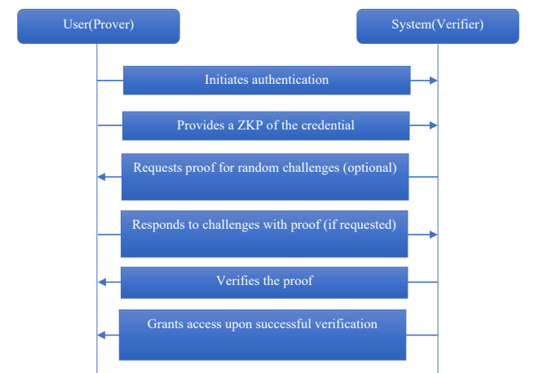
Fig. 2.3.1.1 Zero-Knowledge Proof Sequence Diagram

2.3.2 Feasibility on Resource-Constrained Devices
A primary concern in the literature is whether mobile devices possess the computational power required for ZKP operations. A 2023 study, "A Survey on Zero-Knowledge Authentication for Internet of Things," addressed this by comparing various ZKP schemes on hardware with limited battery and processing power. The survey concluded that Non-Interactive Zero-Knowledge Proofs (NI-ZKP), specifically the Groth16 protocol, are highly efficient due to their minimal proof size. This validates that protocols originally designed for IoT sensors are computationally feasible for modern smartphones.

2.3.3 Application in Identity and Data Integrity
Beyond just logging in, zero-knowledge proofs help manage identities in more meaningful ways. A 2023 study called “Privacy Preserving Identity Management System on Blockchain Using zk-SNARK” showed how zk-SNARKs could work on Ethereum to create decentralized identity systems. It let people prove who they are while keeping private details off record. Still, heavy gas expenses slowed things down when moving transactions through the network. Scalability took a hit because of those charges piling up.
Similarly, a 2025 study titled "A Secure Framework for Privacy-Preserving Analytics in Healthcare Records" utilized ZKP to verify sensitive medical data without exposing patient records. This demonstrated the concept of "Auditability without Visibility”proving that a system can verify a user's authorization status or data validity without ever viewing the underlying sensitive information.

2.4 End-to-End Encryption (E2EE) Protocols

While ZKP addresses authentication privacy, the integrity of the messaging channel itself relies on End-to-End Encryption protocols. Current literature highlights that while the encryption mathematics are sound, the implementation and surrounding processes are vulnerable.

2.4.1 Vulnerabilities in Authentication Ceremonies
A significant weakness in E2EE systems is the method used to verify that encryption keys belong to the intended user. Alatawi and Saxena (2023), in "SoK: An Analysis of End-to-End Encryption and Authentication Ceremonies," analyzed 17 popular messaging applications. They found that while "opportunistic" encryption protects against passive eavesdropping, it fails against active Man-in-the-Middle (MitM) attacks because users neglect manual "Authentication Ceremonies" (e.g., scanning QR codes). The study identified human error in verifying long hexadecimal strings as a critical vulnerability, suggesting that manual verification is functionally broken.

2.4.2 The Insider Threat Landscape
Encryption creates a "blind spot" for monitoring malicious activity originating from authorized users. In "Insider Threat Detection and Secure Data Transfer Leveraging Bidirectional LSTM" (2025), researchers proposed using Bidirectional Long Short Term Memory (Bi-LSTM) networks to analyze user behavior patterns. They found that analyzing the sequence of actions (forward and backward in time) provided higher accuracy in detecting insiders than looking at isolated events.
Still, researchers looked at a 2024 study called "A Review of Recent Advances in Malicious Insider Threat Detection." Though deep learning works okay with big data sets, it has drawbacks according to that piece. One issue stands out: results often lack clear reasoning because systems cannot easily show what they notice. Another problem comes up when some parts of a dataset get very little attention. In insider attack scenarios, real incidents appear infrequently much less than everyday network activity. That gap makes prediction even harder under real-world conditions.

2.4.3 Architecture and Scalability
The underlying architecture of E2EE systems is also a subject of active research. In "Threat Modeling for Enterprise Secure Messaging Applications" (2025), authors used STRIDE threat modeling to identify that while the network layer is encrypted, endpoints remain vulnerable to metadata analysis and session hijacking. Additionally, practical implementation remains complex; a 2025 study on "Implementation of Secure E2EE Chat Application in Microservice Architecture" demonstrated a framework using AES-256 and Diffie-Hellman but relied on standard architectures that do not account for post-quantum threats.
Still, handling growth isn’t easy. According to Barnes and team in 2023, the security setup for messaging - called MLS Protocol follows old patterns seen in older systems such as the Double Ratchet method, where size matters: performance slows down in big circles because it depends on numbers straight up (O(n)). A fresh take called TreeKEM steps in, building on a tree like structure instead of chains; this shift cuts the effort needed to reencrypt data way down to nearly manageable levels (O(log n)). Turns out, end-to-end crypto doesn’t have to shrink when things get busy if we update how we build it.

2.5 On-Device AI Anomaly Detection

The final domain reviewed concerns the detection of the insider threats mentioned in Section 2.4 without compromising the privacy guarantees of E2EE. This requires moving analysis from the cloud to the device (Edge AI).

2.5.1 The Shift to Edge Computing
Natha et al. (2022), in "A Systematic Review of Anomaly detection using Machine and Deep Learning Techniques," highlighted that traditional Machine Learning (like SVM) often underfits complex real-world data, necessitating Deep Learning. Traditionally, Deep Learning required cloud resources, which poses privacy risks.
However, recent advancements have made on-device detection viable. The paper "PHILDER: Lightweight Framework for Intelligent Phishing Detection on Resource-Limited Devices" (2025) demonstrated a compressed Deep Learning model running on ARM-based mobile processors. The researchers achieved over 90% accuracy in detecting threats with less than 100ms latency, proving that heavy cloud servers are not strictly necessary for effective detection.

2.5.2 Mobile Optimization Techniques
Supporting this shift, Gaurav et al. (2025) presented "AI-Driven Smishing Detection in Android Devices Using TinyBERT." By utilizing a TinyBERT transformer model optimized for Android, they achieved 96.81% accuracy, significantly outperforming traditional models like Random Forest. This validates that complex transformer models can be distilled for mobile use.
Furthermore, a 2023 study on "Phishing Detection System Through Hybrid Machine Learning" explored combining algorithms. Their hybrid approach showed that combining "shallow" learning (Random Forest) with "deep" learning features allowed for better extraction of lexical patterns (such as URL length or character randomness) than using a single model alone.

2.6 Summary and Research Gap

The review of existing literature reveals specific strengths in individual technologies but a distinct gap in their integration for SME communication tools.
Summary of Existing Literature:
- Authentication: One issue is checking identities studies show basic E2EE checks often collapse (Alatawi & Saxena, 2023). Though zero knowledge proofs help solve this (Bhattacharya et al., 2024), those methods work more in blockchain or iot setups than everyday messaging tools.
- Encryption & Threats: Though E2EE shields against outside risks, firms lose sight of bad actors already inside. For spotting such behavior, Deep Learning - especially Bi-LSTM methods - works well. Yet nearly all answers depend on analyzing traffic across networks, a move that undoes E2EE's private design.
- Detection: Mobile AI, such as TinyBERT or PHILDER works well for certain jobs, say spotting SMS scams, yet few studies look at using similar tools inside devices to watch how people behave privately online, right as they happen.

Identified Gap: A missing piece remains are no single approach links Zero Knowledge Proofs to on-device AI for spotting unusual user behavior without compromising security. Right now, picking one means choosing between obscurity and insight: protecting information hides risks, while lifting restrictions exposes personal details. A missing piece remains no single approach links Zero-Knowledge Proofs to on-device AI for spotting unusual user behavior without compromising security. Right now, picking one means choosing between obscurity and insight: protecting information hides risks, while lifting restrictions exposes personal details.

2.7 Conclusion
This chapter has presented a critical review of the existing literature related to secure messaging, cryptographic authentication, and mobile anomaly detection. One finding stood out clearly existing E2EE systems depend too heavily on users confirming identities by hand, leaving gaps. Another point emerged: Zero Knowledge Proofs could solve privacy issues during login, yet few messaging apps actually use them. Surprisingly, newer tools in Edge AI now allow powerful threat analysis to operate right inside smartphones. The review confirms that while the individual technologies required to secure SME communications exist, they lack unified integration. The research gaps identified in this chapter specifically the absence of automated trust verification and local behavioral monitoring serve as the primary motivation for this project. These theoretical findings will guide the system design and development approach, which are detailed in the following chapter, Chapter 3: Methodology.

CHAPTER 3

METHODOLOGY

3.1 Introduction

This chapter explains the methodology and the steps taken to develop the SentriZK project and also aims to outline the method behind building, testing, and launching a secure messaging tool. Starting off, it surveys various ways to develop software, explaining why Rapid Application Development stood out as the best fit for this effort.
Following that, the document outlines what happens during every stage of building the system like collecting user needs and creating early versions of the interface. Instead of just listing tasks, it goes deeper into how the platform will be structured from bottom to top. You see visual representations: a map of system components, step-by-step processes, interactive workflows, a guide on navigation paths, along with safeguards against potential weaknesses. Each drawing serves a purpose in making data protection clear and predictable throughout the experience. Moving on, the section covers what equipment and programs need using, along with funding details and a timeline for work steps so everything wraps up when expected. Exactly which tools get used during setup appear here too.

3.2 Overview of Software Development Models

A way to build software lives hidden inside different methods. Picking the right one shapes who gets heard during planning, how layouts take form, when checks happen. This effort looked closely at three paths - Waterfall, Agile, plus a fast version named RAD - to see which fits best. Each path moves development down separate roads. Decisions based on them steer outcomes. Not all work the same once project gets bigger

3.2.1 Waterfall Model
Back in the early days of coding, this method stood out as clear and step-by-step. Instead of loops or stages mixed together, it breaks work into rigid chunks - first figure out needs, then map them logically, after that write code piece by piece. Following that path comes checking for bugs, followed later by release and ongoing fixes whenever issues arise. Each stage wait for its turn before moving forward.
Finish one stage only after getting official permission, then proceed to what comes next. Clear written records matter a lot under this approach - writing down system needs early on sets them firm right at the start.
- Strengths: It keeps things simple through strict stages. When project needs stay clear and unchanged, this approach works well without extra hassle.
- Weaknesses: this method doesn’t adapt well. Once work moves past the testing phase, shifting things becomes tough and expensive. Because of that rigidity, using it feels risky when user needs keep altering. Projects with changing demands might not be the best fit here.
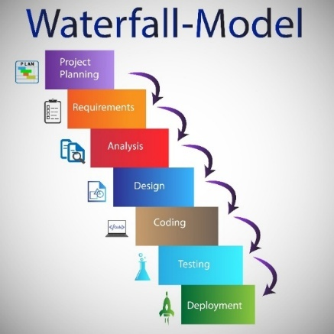

Fig. 3.2.1.1 Diagram Waterfall

3.2.2 Agile Model
Starting differently than the traditional Waterfall method, the Agile approach works through repeated small steps. Instead of delivering everything at once, it breaks work into short cycles often called sprints - for easier tracking and adjustments. Change happens often here because adaptability is built into the process, not forced. Working together matters just as much as meeting user needs on time, since detailed plans are less required at the start.
Change happens often in Agile, because it learns fast. Testing never stops here, woven right into how things grow. Feedback slips in regularly, shaping each step after use shows what works. The result? A system that shifts smoothly when life gets unpredictable.
- Strengths: The Agile model is highly flexible and responsive to changing requirements, with continuous testing helping to identify and resolve issues at an early stage.
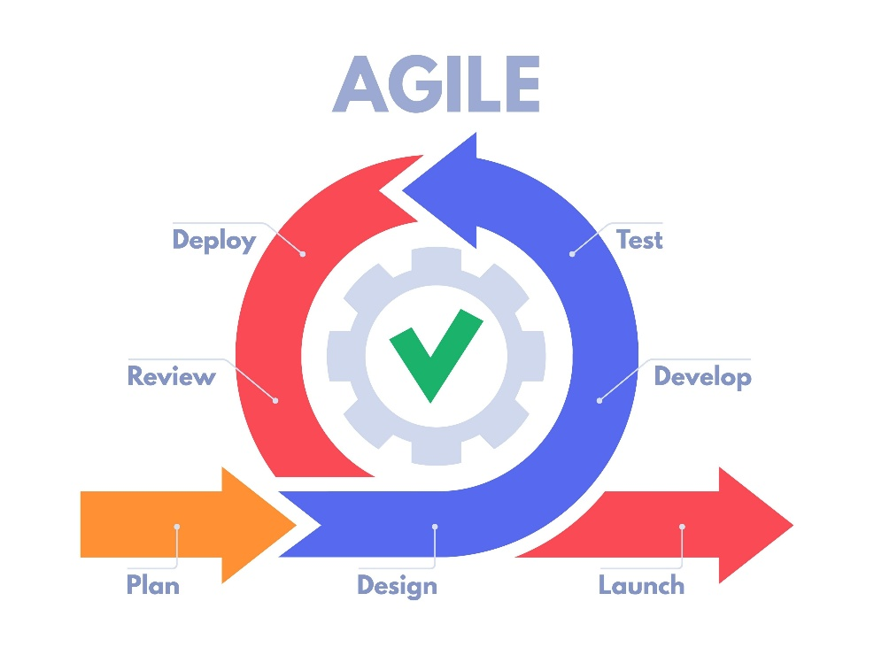
- Weaknesses: Keeping users involved regularly tends to consume steady amounts of effort and personnel. Should oversight lapses, project boundaries might grow beyond intent, possibly slowing things down later.
Fig. 3.2.2.1 Diagram Agile Model

3.2.3 Rapid Application Development (RAD)
In rapid application development, quick prototypes take center stage alongside constant input from users instead of long term blueprints. Instead of breaking work into separate stages like typical methods do, RAD packs analysis, planning, building, and checking together in rapid loops. Each loop delivers working pieces faster than traditional steps would allow.
Right off, one thing stands out in RAD: working samples appear fast. These rough versions get shown to users or managers before long. Feedback comes back quickly, shaping changes that keep moving forward.
- Strengths: With RAD, systems come together fast timelines shrink quickly. Because it lets people see the app sooner, there’s better alignment with what users actually need.
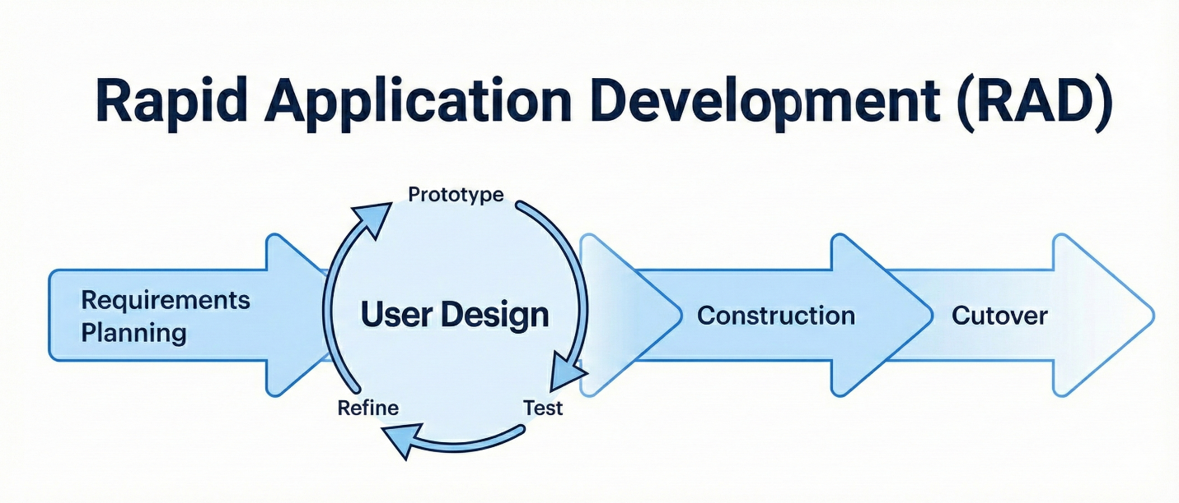
- Weaknesses: One issue with RAD is how it demands modules built separately, something tricky in certain work settings. Yet when deadlines loom close say, near the end of a student's last semester its fast pace and early testing loops become surprisingly useful.

Fig. 3.2.3.1 Diagram Agile Model

3.3 Proposed Methodology

After looking at different ways to develop software, as mentioned earlier, the choice landed on Rapid Application Development simply because it fits best here.
What made us pick RAD wasn’t just speed - it’s how fast you can build, then tweak. Instead of sticking to fixed steps, we leaned into making things quickly, over and over. For this work, splitting tasks into smaller chunks helped keep changes manageable. Testing pieces early came naturally here, since new ideas often pop up unexpectedly. Other methods might slow down when details shift - this one didn’t blink. From start to finish, we went through steps like defining needs, shaping layouts, building features, then switching to the new version.

Justification for Choosing RAD
The Rapid Application Development (RAD) methodology was selected primarily for its emphasis on early visualization and iterative prototyping. Accurately capturing user requirements is frequently challenging in software development. RAD addresses this by prioritizing the rapid creation of functional mock-ups, allowing stakeholders to interact with early iterations of the system. This hands-on approach ensures that both the design and core features are validated prior to final implementation, significantly reducing the likelihood of misaligned requirements.

Furthermore, the strict time constraints inherent to a final year project necessitate an efficient development lifecycle. Traditional sequential methodologies often face critical delays if defects are discovered during late-stage testing. Conversely, RAD accelerates development through the utilization of pre-built components and the parallel execution of tasks. This expedited approach is crucial for delivering a fully functional system within the fixed academic timeframe.

Another significant advantage of RAD is its inherent flexibility and adaptability. During the development phase, iterative evaluations and feedback often lead to modifications in system requirements. The RAD framework is designed to accommodate these changes seamlessly into the work-in-progress without causing substantial project delays. This adaptability presents a distinct advantage over more rigid, linear frameworks such as the Waterfall model.

Finally, this methodology facilitates effective risk mitigation. By modularizing the system into smaller, manageable components, potential vulnerabilities and defects can be identified and addressed at an earlier stage. Independent testing of these modules ensures that localized issues are resolved promptly without impeding the progress of the overall development effort, thereby minimizing the risk of comprehensive project delays.

3.4 Phases of Development

The development of SentriZK follows the Rapid Application Development (RAD) lifecycle. This approach was selected to allow for the parallel development of the three core modules: Zero-Knowledge Authentication, End-to-End Encryption (E2EE), and AI Anomaly Detection. The lifecycle consists of four distinct phases: Requirements Planning, User Design, Construction, and Cutover.

3.4.1 Phase 1: Requirements Planning
The primary objective was to define the integration points between security, privacy, and intelligence.
Data Collection & Scope Definition
- Stakeholder Consultation: Discussions with NISHA SUTERA ENTERPRISE highlighted the need for a system that not only secures login (Auth) but also protects trade secrets in transit (E2EE) and proactively filters malicious links (ML) without manual oversight.
- Dataset Acquisition (For ML): To train the Anomaly Detection module, public datasets containing phishing URLs and social engineering text patterns were gathered to train the TensorFlow Lite model.
- Cryptographic Standards Review: The Signal Protocol and ECDH (Elliptic Curve Diffie-Hellman) were analyzed to ensure the E2EE module meets industry standards alongside the ZKP implementation.

3.4.2 Phase 2: User Design
In this phase, the technical architecture was designed to ensure these three modules could coexist without performance degradation.

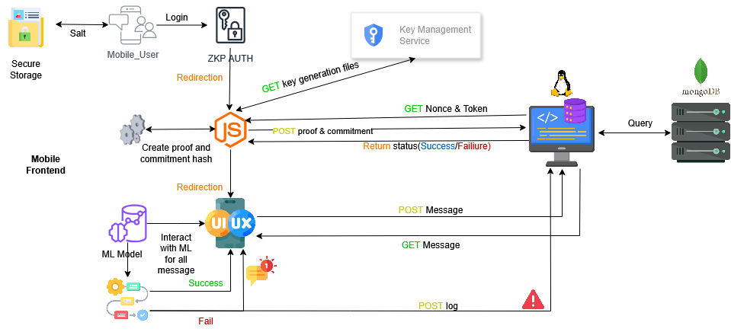
- System Architecture Design: The architecture is designed as a "Privacy-First" ecosystem. The diagram below illustrates the Client-Side processing, showing how the AI Engine sits before the Encryption Layer, ensuring the server only ever receives opaque, encrypted data.

Fig. 3.4.2.1 SentriZK System Architecture

- Component Interaction Diagrams: Three specific diagrams were designed to map the core functionalities:
  - ZKP Registration Sequence Diagram: A detailed sequence diagram illustrating the hybrid mobile-web workflow for secure user registration. It maps the generation of a temporary Mobile Access Token (MAT), the handoff to a web interface for computationally intensive ZKP proof generation, the server-side verification using the Verification Key (VK), and the secure return to the mobile application via deep linking.
  - E2EE Key Exchange Sequence: A diagram designing the flow of public key exchange and shared secret derivation (ECDH). It visualizes how ephemeral keys are generated and exchanged so that messages are fully encrypted before network transmission, ensuring the server never sees plaintext.

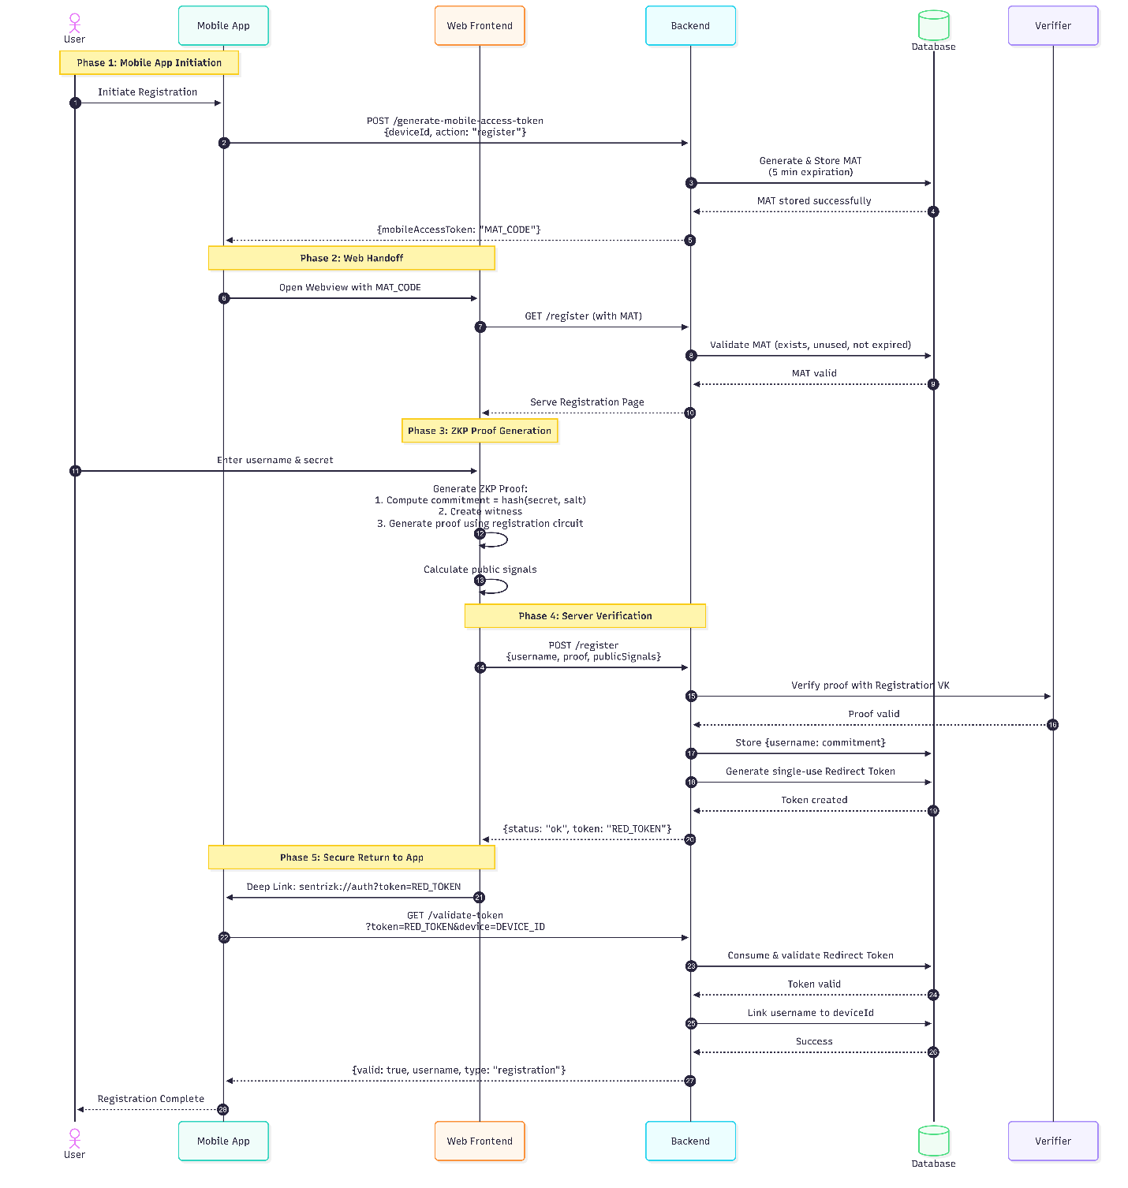

Fig. 3.4.2.2 SentriZK Sequence Diagram

- Process Flowchart: A high-level flowchart was designed to visualize the end-to-end operational logic between the Authentication, Sender, and Receiver entities. It delineates the system's decision-making process:
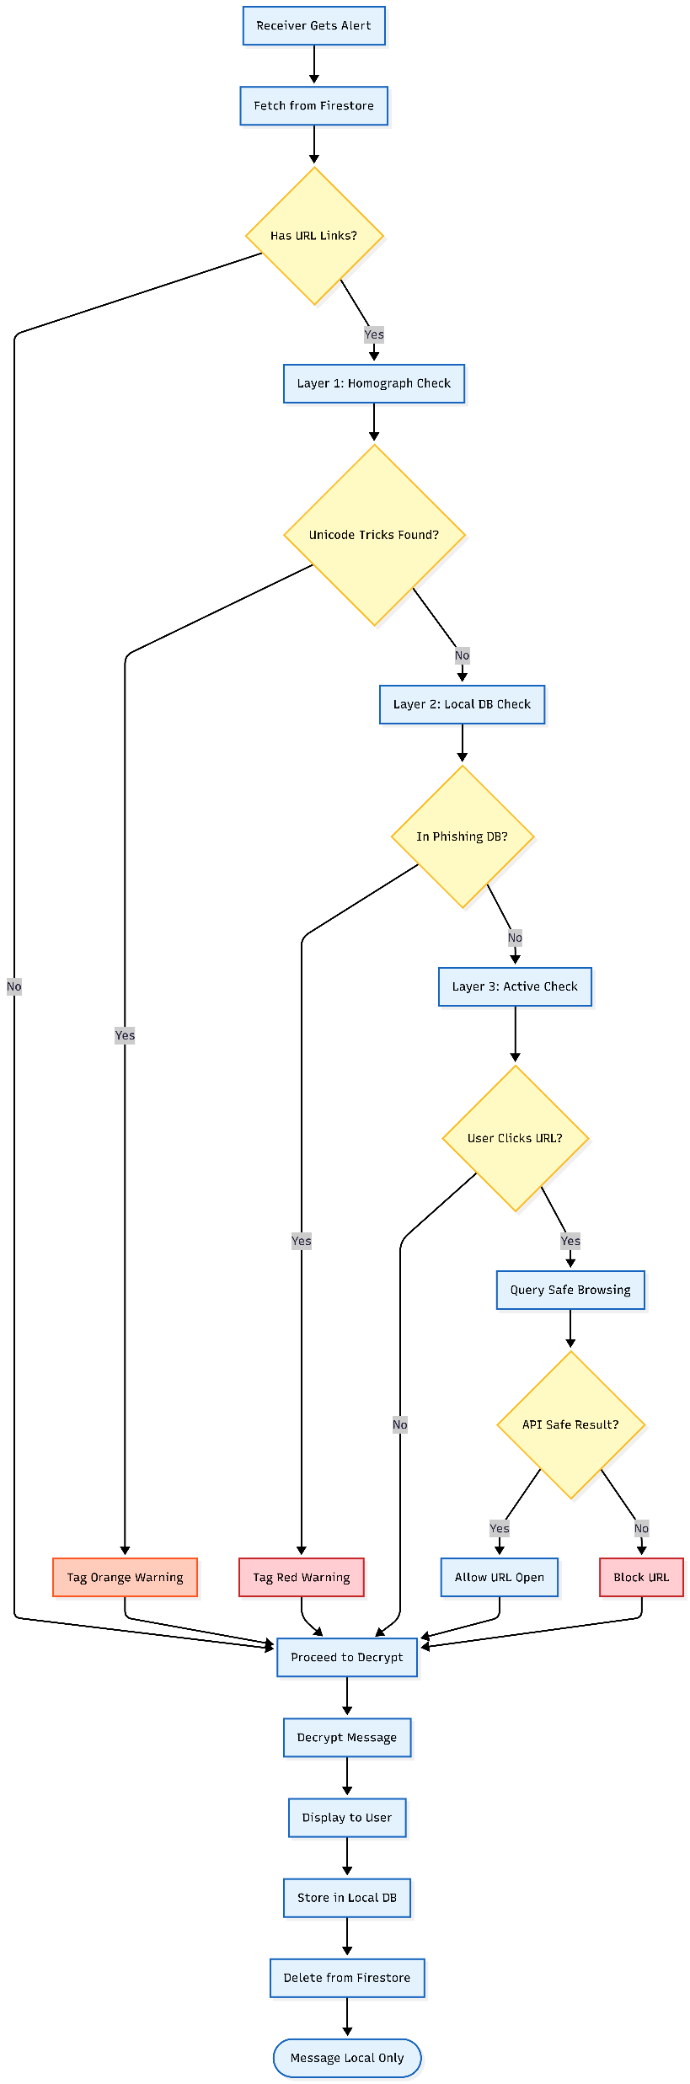
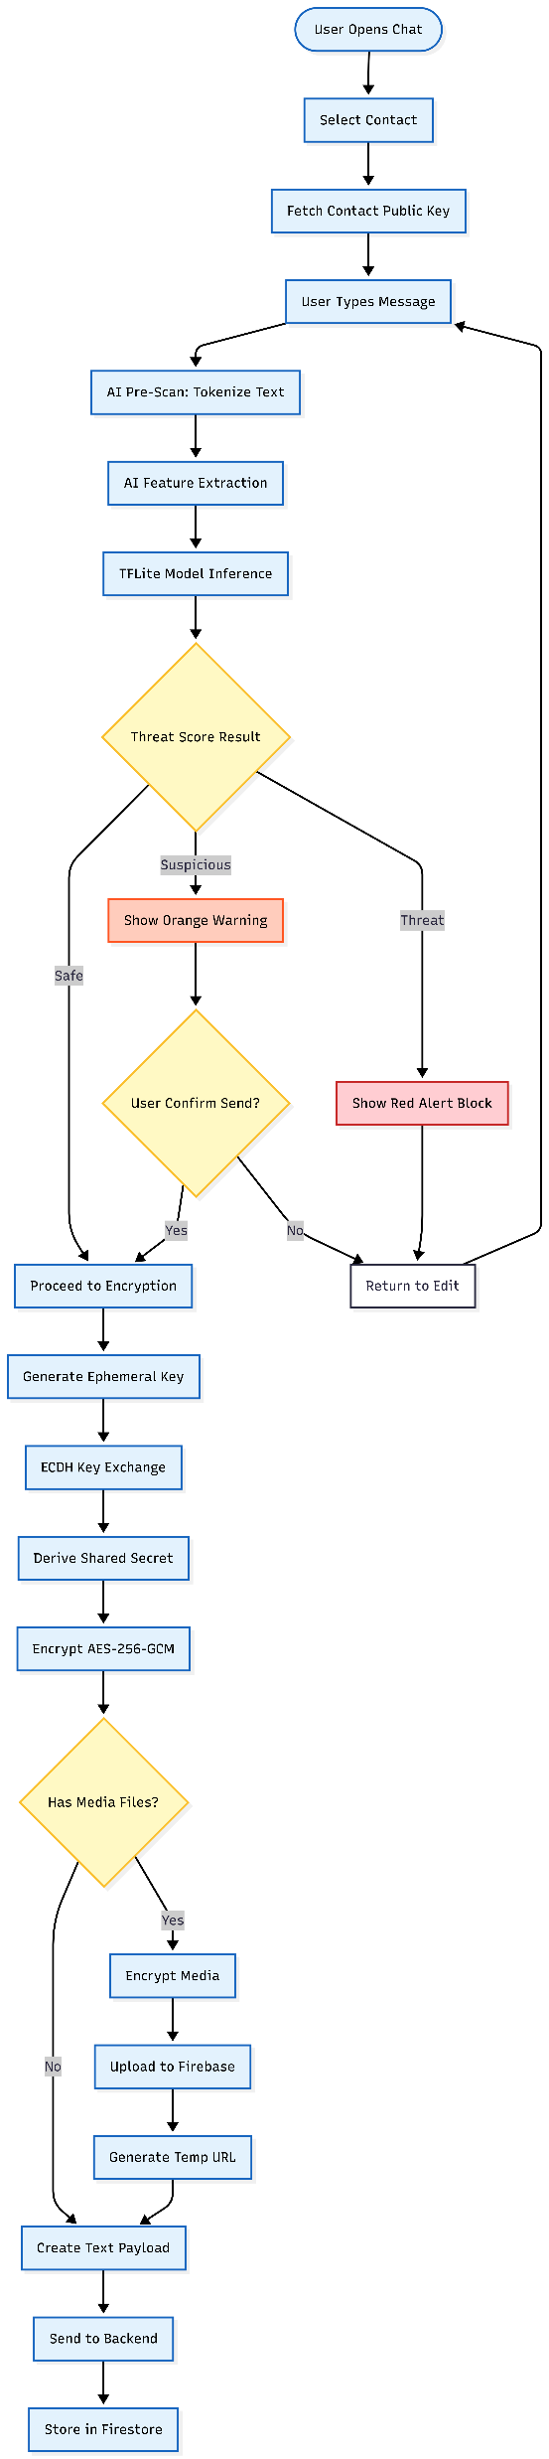
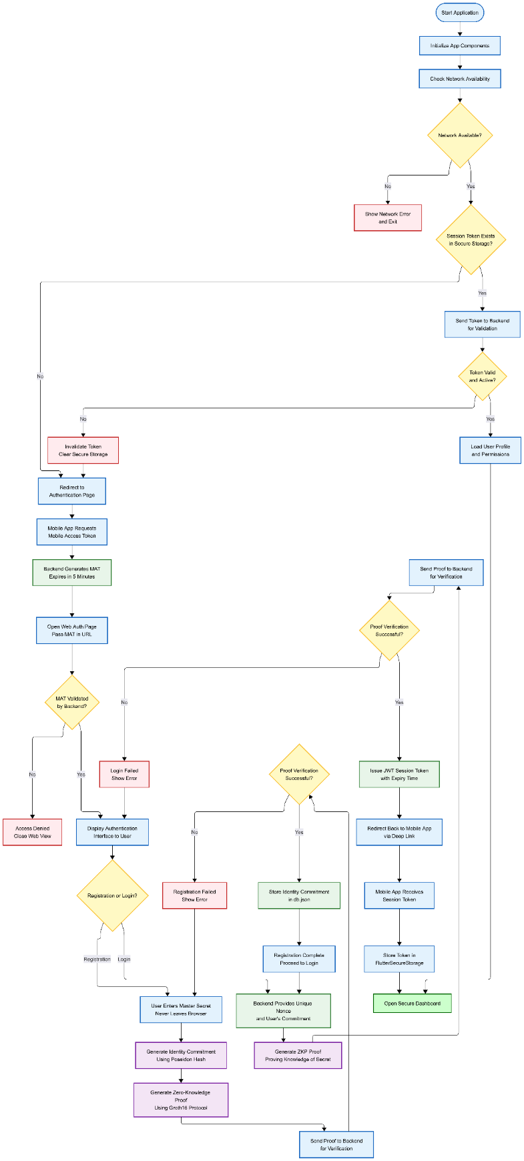

Fig. 3.4.2.3 SentriZK Flow chart
- Use Case Diagram: The Use Case diagram was designed to define the system's functional scope and actor interactions. It identifies the "SME Employee" as the primary actor and maps their engagement with the system's three core security modules

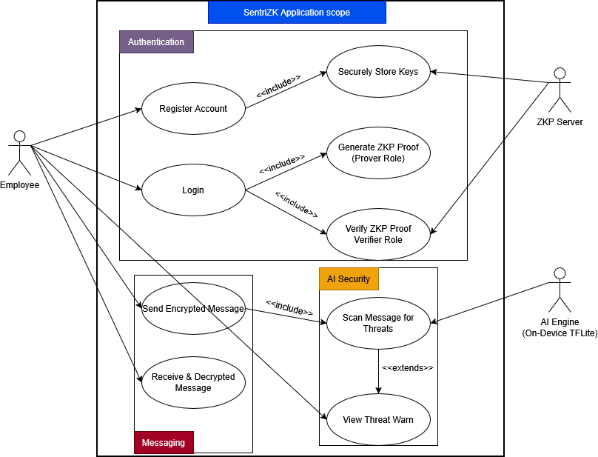

Fig. 3.4.2.4 SentriZK Use Case Diagram

- Threat Model Diagram The threat model for the application was expanded to address vulnerabilities at three critical layers: the Client, the Network, and the Server. The diagram visualizes the specific attack vectors the system is designed to neutralize
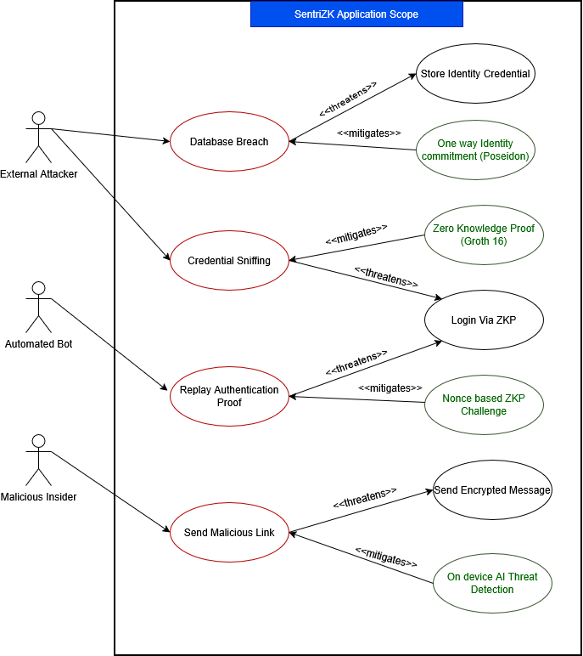
Fig. 3.4.2.5 SentriZK Misuse Case Diagram

3.4.3 Phase 3: Construction
This phase focused on the actual programming and integration of the system's three core modules. The development process was divided into specific tasks for authentication, encryption, and threat detection.

Module A: Zero Knowledge Authentication
The development of the authentication module began with writing custom cryptographic circuits using the Circom language. These circuits were designed to define the constraints for proving knowledge of a password without revealing it. Following the circuit design, a "Trusted Setup" (Powers of Tau) ceremony was conducted to generate the proving and verification keys required for the zk-SNARK protocol. Finally, the snarkjs library was integrated into the client application. This integration allowed the mobile app to generate mathematical proofs locally, enabling users to verify their identity to the server without ever transmitting their actual credentials.

Module B: End-to-End Encryption
For the messaging module, the application was programmed to enforce privacy by default. Upon user registration, the system automatically generates ephemeral key pairs using the Ed25519 elliptic curve. An AES-256-GCM encryption protocol was implemented using the crypto-js library to handle message payloads. The logic was programmed so that when User A sends a message to User B, the system first derives a shared secret locally on the device, encrypts the message payload, and only then sends the ciphertext to the server. To ensure the safety of these keys, the flutter_secure_storage library was utilized to store private keys within the hardware-backed Android KeyStore or iOS Keychain.

Module C: AI Anomaly Detection
The threat detection module involved training Machine Learning models to recognize security risks. An Isolation Forest and Autoencoder model were trained using gathered datasets containing patterns of social engineering and malicious URLs. Once trained, the models were optimized and converted into the TensorFlow Lite format, ensuring the file size remained under 10MB for efficient mobile performance. This optimized model was then embedded directly into the Flutter client. It was programmed to intercept user input in real-time, assigning a "Threat Score" to outgoing messages. If this score exceeds a predefined threshold, the system triggers a warning to the user before the message is encrypted and sent.

3.4.4 Phase 4: Cutover
The Cutover phase is the final step where the system transitions from a development build to a functional prototype ready for demonstration. This phase is scheduled to happen immediately after the construction phase is finished.

Integration Testing:
In this step, the three separate modules ZKP Authentication, E2EE, and AI will be combined into a single cohesive application. Rigorous testing will be conducted to ensure they work together smoothly. A major focus here is to verify that the on-device AI inference is fast enough; it must not introduce noticeable lag (latency) that would delay the encryption process or make the "Send" button feel unresponsive.

Security Audits:
A comprehensive security review is planned to validate that the system actually protects data as intended. This involves specific technical tests:
- Replay Attacks: Will attempt to capture an old login proof and send it to the server again to verify that the system's "nonce" mechanism correctly rejects the duplicate request.
- Simulated Database Breach: Will access the backend database directly to confirm that an attacker would only find useless ciphertext and mathematical commitments, proving that no readable user data is stored.
- AI Model Testing: The AI model will be tested against a fresh dataset of phishing links to calculate its detection accuracy and ensure it provides valid warnings.

User Acceptance Testing (UAT):
The final prototype will be presented to the staff at NISHA SUTERA ENTERPRISE. They will be asked to use the system in a controlled environment to perform their standard daily communication tasks. The objective is to verify that security measures specifically the AI threat warnings are helpful and do not intrude upon their daily operational workflow. The feedback collected from this session will be used to make any final adjustments to the interface or sensitivity settings before the project is concluded.

3.5 System Requirements

This section outlines the hardware and software resources utilized to develop and test the SentriZK system. Given the project's focus on "privacy-first" security, the technical setup required specific tools capable of handling cryptographic generation and on-device AI processing without relying on external cloud processing.

3.5.1 Hardware Requirements
The hardware selection was divided into high-performance development units and low-cost deployment units to demonstrate the system's feasibility for Small and Medium Enterprises (SMEs).

- Development Workstation (Lenovo Legion)
A high-specification laptop was required for the primary development phase. The inclusion of a dedicated GPU was essential for training the Isolation Forest AI models, a task that demands significant computational power. Furthermore, running the Android Studio emulator concurrently with the Node.js backend required a minimum of 16GB RAM to maintain a stable testing environment.
- Mobile Test Device (Physical Android Phone)
Although emulators were used for initial interface design, a physical Android device was necessary for final system verification. Real hardware was required to accurately test the camera performance for scanning ZKP QR codes and to assess the biometric authentication sensors. Testing on a physical device also provided critical data regarding battery consumption and heat generation during the AI inference process.
- Server Node (Raspberry Pi 5 - 8GB)
To avoid the recurring costs associated with cloud hosting services like AWS, a Raspberry Pi 5 was deployed as the primary server. This device hosts the backend API and database. The 8GB RAM model was selected to ensure sufficient memory for handling concurrent verification requests, demonstrating that the entire security architecture can run on accessible, low-cost hardware.

3.5.2 Software Requirements
The software stack consists of open-source tools selected for their security features and mobile compatibility.

- Flutter: This framework was selected for mobile development to ensure efficiency. It allowed for the creation of a single codebase that functions across various Android versions without requiring extensive native code adjustments.
- GetX: This library was utilized for state management, simplifying the data flow between the secure login screens and the encrypted chat interface.
- Next.js: A web-based interface was developed using Next.js to handle the computationally intensive ZKP key generation, which can be resource-heavy for older mobile devices.
- Node.js: The backend logic is built upon the Node.js runtime. It was chosen for its lightweight architecture and efficient handling of JSON data packets sent from the mobile client.
- Cloudflare Tunnel: To secure the local Raspberry Pi server without exposing it via risky router port forwarding, Cloudflare Tunnel was implemented. This service provides a secure, encrypted connection to the internet for external access.
- Firebase: This service is utilized strictly for "signaling" purposes—notifying a user that a message is waiting without storing the actual message content.
- TensorFlow Lite: The original Machine Learning models were converted into the TensorFlow Lite format. This optimization was necessary to reduce the file size, allowing the Isolation Forest model to run locally on the device for real-time threat detection.
- SnarkJS: This JavaScript library is integral to the system, handling the mathematical generation of Zero-Knowledge Proofs on the client side and verification on the server side.
- Hive DB: For local data storage, Hive DB was implemented due to its superior read/write speeds compared to traditional SQL databases, ensuring quick access to encrypted chat history.

3.5.3 Budget and Costing
The primary objective of this project was to demonstrate a cost-effective security solution for SMEs. By adopting a self-hosted architecture, the project successfully eliminated most recurring monthly subscription costs.
The table below categorizes the financial resources into "Assets" (existing equipment reused for the project) and "Expenditure" (actual funds utilized).
Item | Category | Cost (RM) | Description
Development Hardware
Lenovo Legion Laptop | Asset | 4,500.00 | Existing workstation used for coding and training.
Android Test Phone | Asset | 800.00 | Physical devices are used for hardware-level testing.
Server Infrastructure
Raspberry Pi 5 (8GB) | Asset | 400.00 | Self-hosted server node to eliminate cloud fees.
Software & Services
Cloudflare Tunnel | Service | 0.00 | Free Tier (Zero Trust) for secure remote access.
Firebase (Spark Plan) | Service | 0.00 | Free Tier is utilized for signaling only.
Project Expenditure
Domain Name (.com) | Cash Out | 80.00 | 1 year registration fee for the web identity.
TOTAL COST |  | RM 80.00 | Total actual cash expenditure.

Table 3.5.3.1: Project Cost Breakdown

3.6 Project Planning

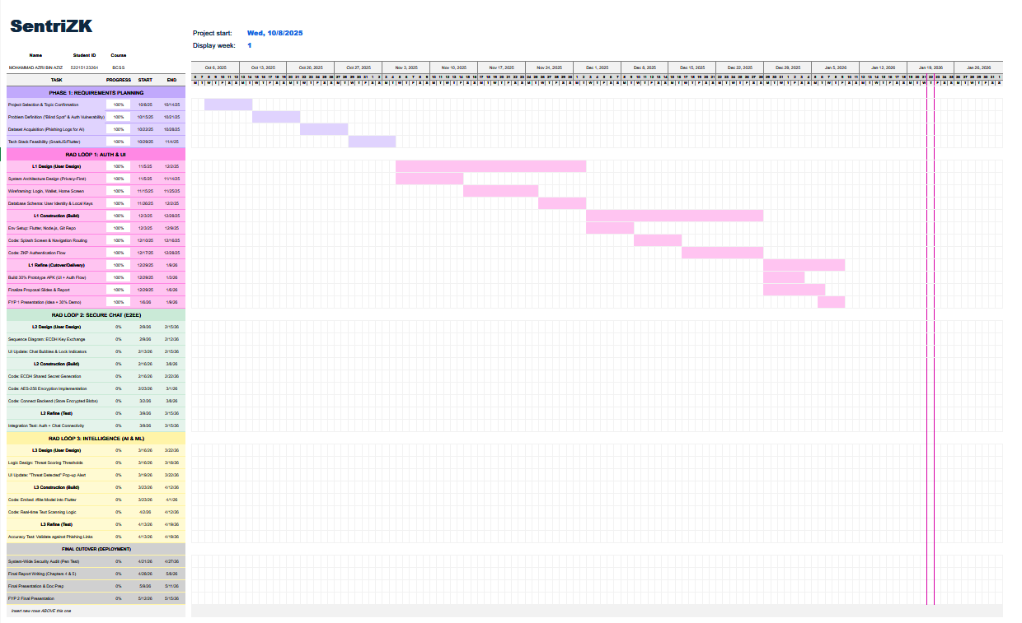
Gantt Chart Link: Excel_File_Link
Figure 3.6.1: Project Gantt Chart Summary

3.7 Chapter Summary
To conclude, this chapter explained the methodology and tools selected to develop the SentriZK project. The Rapid Application Development (RAD) model was chosen because it allows the three main security modules to be built and tested in cycles, rather than waiting for one massive phase to finish. The technical design was also mapped out using specific diagrams, such as the system architecture and threat model, to give a clear picture of how the "Privacy First" logic actually works.
Additionally, this chapter listed the required hardware and software, confirming that the project can be deployed on a tight budget using self-hosted tools like the Raspberry Pi. Now that the design and planning are clear, the next stage is the actual building of the system. The next chapter, Chapter 4: System Development, will document the practical steps taken to write the cryptographic code, train the AI models, and integrate everything into the mobile application.

CHAPTER 4

SYSTEM DEVELOPMENT

4.1 Introduction
This chapter documents the practical development of the SentriZK secure messaging system, translating the architecture and design presented in Chapter 3 into a working software product. Where Chapter 3 described the intended methodology and high-level design, this chapter reports what was actually engineered, the tools and frameworks that were used, and the technical decisions taken during construction. The discussion follows the Rapid Application Development (RAD) lifecycle adopted for this project, in which the three core security modules Zero-Knowledge Proof (ZKP) authentication, end-to-end encrypted (E2EE) messaging, and on-device Artificial Intelligence (AI) threat detection were built and refined in overlapping increments.
The chapter begins by defining the development environment, frameworks, and software dependencies of each component. It then describes the installation, setup, and configuration of the backend server, the cryptographic circuits, the web portal, the mobile application, and the machine-learning pipeline. The implementation of each of the three security modules is presented in detail, followed by the user-interface and experience design, the system integration that binds the components together, the source-code management and version evolution of the project, and finally the deployment environment. It should be noted that several implementation choices evolved beyond the original proposal as the prototype matured; these deviations are highlighted and justified as informed engineering decisions at the relevant points in this chapter.

4.2 Development Environment and Tools
SentriZK was developed as a single Git monorepository containing four cooperating sub-projects: a Node.js backend, a Next.js web portal, a Flutter mobile application, and a Python machine-learning pipeline. This section defines the hardware, operating systems, integrated development environments (IDEs), languages, runtimes, and the full set of third-party dependencies used to build the system.

4.2.1 Hardware and Operating System
Development was carried out primarily on a Windows 11 workstation (a Lenovo Legion laptop with a dedicated GPU and 16 GB of RAM). The dedicated GPU was used to accelerate the training of the neural-network threat-detection models, while the 16 GB of memory allowed the Android emulator, the Node.js backend, and the Next.js development server to run concurrently. A physical Android device (minimum Android 10, API level 29) was used for final verification of camera access, biometric prompts, push notifications, deep-link handling, and on-device model inference, none of which can be assessed reliably on an emulator. Table 4.1 summarises the development and test hardware.
Table 4.1: Development and Test Hardware
Unit | Role | Key Specification
Lenovo Legion laptop | Primary development & ML training | Windows 11, dedicated GPU, 16 GB RAM
Physical Android phone | On-device verification | Android 10+ (API 29+), real sensors
Server node | Backend / database host | Self-hosted Linux node, 8 GB RAM

4.2.2 Integrated Development Environments and Tooling
Visual Studio Code was used as the principal IDE for the backend, web, and machine-learning code, while Android Studio provided the Android SDK, emulator, and Gradle build toolchain required for the Flutter application. Git was used for version control throughout, with the remote repository hosted on GitHub. Supporting command-line tools included the Node.js package manager (npm), the Flutter and Dart command-line tools, the Circom compiler and the snarkjs toolchain for the zero-knowledge circuits, and ngrok for exposing the local backend to mobile devices during testing.

4.2.3 Frameworks, Languages and Runtimes
The system is polyglot by necessity, because each tier has different performance and ecosystem requirements. The backend is written in JavaScript on the Node.js runtime (version 18 or higher) using the Express 5 web framework. The web portal is written in TypeScript using Next.js 15.5.6 with React 19. The mobile application is written in Dart (SDK 3.8) using the Flutter framework. The zero-knowledge circuits are written in the Circom 2.0.0 domain-specific language and proven with the Groth16 zk-SNARK system over the BN128 elliptic curve. The machine-learning pipeline is written in Python using TensorFlow 2.20 and Keras 3.13. Table 4.2 lists the core framework of each tier.
Table 4.2: Core Framework of Each System Tier
Tier | Language | Framework / Runtime
Backend API | JavaScript | Node.js 18+, Express 5.1
Web portal | TypeScript 5 | Next.js 15.5.6, React 19.1
Mobile app | Dart 3.8 | Flutter 3.8
ZK circuits | Circom 2.0.0 | Groth16 / BN128 (snarkjs 0.7.5)
ML pipeline | Python | TensorFlow 2.20, Keras 3.13

4.2.4 Software Dependencies
Each sub-project relies on a curated set of open-source libraries. The backend depends on snarkjs for Groth16 proof verification, circomlibjs for the Poseidon hash function, the Supabase client for PostgreSQL access, the Firebase Admin SDK for push notifications and custom-token issuance, and a set of standard security middleware (express-rate-limit, jsonwebtoken, bcryptjs, cors). The principal backend dependencies are listed in Table 4.3.
Table 4.3: Principal Backend Dependencies
Package | Version | Purpose
express | 5.1.0 | HTTP/REST framework (port 6000)
snarkjs | 0.7.5 | Groth16 zk-SNARK proof verification
circomlibjs | 0.1.7 | Poseidon hash / BN128 field arithmetic
@supabase/supabase-js | 2.101.1 | Supabase PostgreSQL client
firebase-admin | 13.0.0 | FCM push, Firestore admin, custom tokens
express-rate-limit | 8.1.0 | Brute-force / rate-limit protection
jsonwebtoken | 9.0.3 | Admin session JWT (HS256)
bcryptjs | 3.0.3 | Admin password hashing

The web portal depends on snarkjs and circomlibjs to generate zero-knowledge proofs inside the browser, together with bip39 for recovery-phrase generation, js-sha3 for username hashing, crypto-js for client-side salt encryption, and axios for backend communication. Table 4.4 lists the principal web dependencies.

Table 4.4: Principal Web Portal Dependencies
Package | Version | Purpose
next / react | 15.5.6 / 19.1.0 | Web application framework
snarkjs | 0.7.5 | In-browser Groth16 proof generation
circomlibjs | 0.1.7 | Poseidon / field arithmetic
bip39 | 3.1.0 | 24-word recovery mnemonic
js-sha3 | 0.9.3 | SHA3-256 username / address hashing
crypto-js | 4.2.0 | AES salt-envelope encryption (browser)
axios | 1.12.2 | REST calls to the backend

The mobile application has the largest dependency surface because it hosts the messaging, encryption, on-device inference, calling, and notification features. Its most significant dependencies are listed in Table 4.5. Two of these choices differ from the original proposal and are discussed further in the relevant sections: the Signal Protocol implementation libsignal_protocol_dart is used for message encryption in place of a bespoke scheme, and the Isar embedded database is used for local storage in place of Hive. State management uses the lightweight provider package rather than GetX.

Table 4.5: Principal Mobile Application Dependencies
Package | Version | Purpose
libsignal_protocol_dart | 0.7.2 | Signal Protocol (X3DH + Double Ratchet) E2EE
tflite_flutter | 0.12.0 | On-device TensorFlow Lite inference
isar / isar_flutter_libs | 3.1.0 | Embedded reactive NoSQL database
flutter_secure_storage | 10.0.0 | Android Keystore / iOS Keychain storage
provider | 6.1.5 | State management (ChangeNotifier)
app_links / url_launcher | 7.0.0 / 6.3.2 | Deep-link bridge to the web portal
cloud_firestore / firebase_messaging | latest | Ciphertext relay and FCM push
flutter_webrtc | 0.12.1 | Audio / video calling (DTLS-SRTP)
cryptography | 2.5.0 | AES-256-GCM recovery-salt envelope

The machine-learning pipeline depends on TensorFlow and Keras for model construction and TensorFlow Lite conversion, scikit-learn for the train/validation split and evaluation metrics, pandas and numpy for data handling, and matplotlib with seaborn for generating the evaluation charts. The training environment also includes a CUDA-enabled build of PyTorch, which was used during experimentation.

4.3 System Architecture as Implemented
The realised system is organised into four tiers that cooperate over the network. The Flutter mobile application is the primary client used by employees for messaging and calling. A Next.js web portal acts as a dedicated cryptographic surface that performs the computationally heavy zero-knowledge proof generation that the mobile device cannot run efficiently. A Node.js/Express backend verifies proofs, manages sessions, and brokers notifications. Persistence is split between a Supabase PostgreSQL database, which stores authentication state, and Firebase Firestore, which relays encrypted messages and supports real-time features. Figure 4.1 presents the full system architecture as it was implemented.
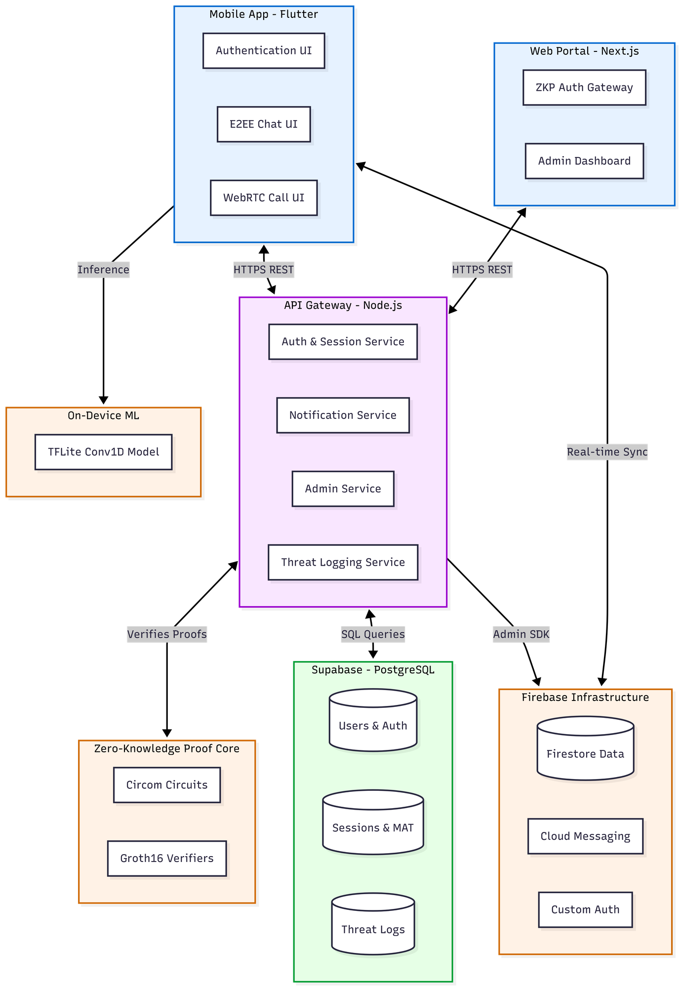
Figure 4.1: SentriZK Full System Architecture (as implemented)

A defining principle of the architecture is that the server never holds material that would be valuable to an attacker. The backend stores only Poseidon commitments rather than passwords, and the messaging tier stores only Signal Protocol ciphertext rather than plaintext. The internal structure of the mobile client — its services for authentication, messaging, encryption, scanning, and notifications is shown in Figure 4.2.

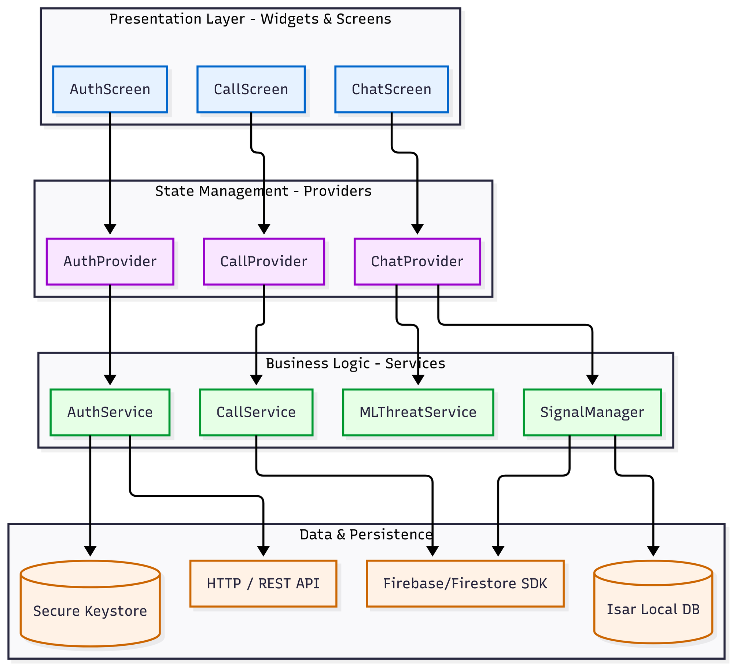
Figure 4.2: Component Diagram of the Flutter Mobile Application

4.4 Installation, Setup and Configuration
This section describes how each component is installed and configured. Configuration is centralised so that environment-specific values service URLs, database credentials, and cryptographic artefact paths are kept out of the source code. The backend and test tooling read configuration from .env files; the web portal reads public configuration from NEXT_PUBLIC_ environment variables; and the mobile application reads its endpoints from a single app_config.dart file with an optional .env override.

4.4.1 Backend Server Setup
The backend is installed with npm install inside the Backend directory and started with node server.js, after which it listens on port 6000 and binds to all interfaces. Before it will start, several pieces of configuration must be present. A .env file must supply the Supabase URL and service-role key, the administrator credentials, and the JWT signing secret; the server deliberately refuses to start if any of these are missing. A Firebase service-account key file must be present so that the Admin SDK can issue custom tokens and send push notifications. The two zero-knowledge verification keys must be present on disk, and the Poseidon hash function is built once at start-up; endpoints that depend on it return a temporary unavailable status until it is ready. Finally, the Supabase schema script must be applied to create the five database tables and their indexes.
Table 4.6: Backend Environment Configuration
Variable | Purpose
SUPABASE_URL / SUPABASE_SERVICE_ROLE_KEY | PostgreSQL connection (required)
ADMIN_USERNAME / ADMIN_PASSWORD | Admin dashboard credentials
JWT_SECRET / JWT_TTL | Admin JWT signing key and lifetime (default 1h)
PORT | Listening port (default 6000)
serviceAccountKey.json | Firebase Admin SDK private key (file)

4.4.2 Zero-Knowledge Circuit Compilation and Trusted Setup
The two Circom circuits are compiled with the Circom 2.0.0 compiler into a WebAssembly witness generator and an R1CS constraint system. A Groth16 trusted setup is then performed with snarkjs: a Powers-of-Tau phase produces the universal parameters, a circuit-specific phase-two contribution produces the proving key (a .zkey file), and the verification key is exported as JSON. The proving keys and WebAssembly witness generators are copied into the web portal so that proofs can be generated in the browser, while the verification keys are loaded by the backend. The compiled artefacts are compact: the registration witness generator is approximately 1.84 MB and its proving key approximately 459 KB, while the login witness generator is approximately 2.17 MB and its proving key approximately 740 KB.

4.4.3 Web Portal Setup
The web portal is installed with npm install inside the Frontend/web directory and run with npm run dev for development or built with npm run build for production, both using the Turbopack bundler. Its configuration consists of the backend API URL and the four paths to the circuit artefacts (the login and registration WebAssembly and proving-key files), which are served as static assets from the public directory. No secret values are stored in the web tier, because all sensitive cryptographic material is derived transiently on the client and never persisted.

4.4.4 Mobile Application Setup
The mobile application is installed with flutter pub get inside the Frontend/mobile directory and run with flutter run on a connected device or built for release with flutter build apk. Its endpoints are configured in a single app_config.dart file, which points the application at the backend API and the web portal and defines the custom deep-link scheme, the session and token lifetimes, and the machine-learning thresholds. Firebase is configured through the standard google-services.json file, and an optional .env file supplies the Google Safe Browsing API key.

4.4.5 Machine-Learning Pipeline Setup
The machine-learning pipeline is a self-contained Python project. After the dependencies are installed, the single training script is executed to read the prepared dataset, train the models, convert the mobile model to TensorFlow Lite, and export the vocabulary file. The two output artefacts the quantised model and its vocabulary are then copied into the mobile application's asset bundle, from where they are loaded at runtime.

4.5 Implementation of the Core Security Modules
The construction phase concentrated on three modules that together deliver the project's objectives: zero-knowledge authentication, end-to-end encrypted messaging, and on-device AI threat detection. Each module is presented below in terms of what was built, the specific techniques used, and, where applicable, how and why the implementation departed from the original proposal.

4.5.1 Module A: Zero-Knowledge Proof Authentication
The authentication module replaces password transmission with a zero-knowledge proof of knowledge. Two Circom 2.0.0 circuits were written. The registration circuit computes a single Poseidon commitment from the user's secret, a salt, and a hash of the username; the secret is range-checked to 256 bits and the salt to 128 bits. The login circuit recomputes that commitment from the same private inputs, asserts that it equals the commitment stored on the server, and additionally outputs a Poseidon session value that binds the proof to a fresh server-issued nonce. The two circuits compile to 991 and 1,573 rank-one constraints respectively, confirming that the proofs are small enough to generate and verify quickly. Table 4.7 summarises the circuit parameters.

Table 4.7: Zero-Knowledge Circuit Parameters
Property | Registration circuit | Login circuit
Commitment | Poseidon(secret, salt, unameHash) | recomputed and asserted equal
Private inputs | secret (256-bit), salt (128-bit) | secret, salt
Public inputs | unameHash | unameHash, storedCommitment, nonce (64-bit)
Outputs | commitment | pubCommitment, pubSession
R1CS constraints | 991 | 1,573
Proving system | Groth16 / BN128 | Groth16 / BN128

A practical constraint shaped the most significant design decision in this module. Groth16 proof generation depends on the snarkjs WebAssembly prover, which a Flutter application cannot execute efficiently on-device. Rather than weaken the cryptography, the implementation delegates proof generation to the web portal through a short-lived Mobile Access Token (MAT). When the user initiates registration or login, the mobile application requests a single-use, device-bound MAT that is valid for five minutes, then opens the system browser to the web portal carrying that token. The browser performs the heavy proof generation and submits the proof to the backend, and the result is returned to the application through a custom sentriapp:// deep link. This bridge keeps every secret on the user's own devices while moving only the computational burden to the browser. The registration and login sequences are shown in Figure 4.3 and Figure 4.4.
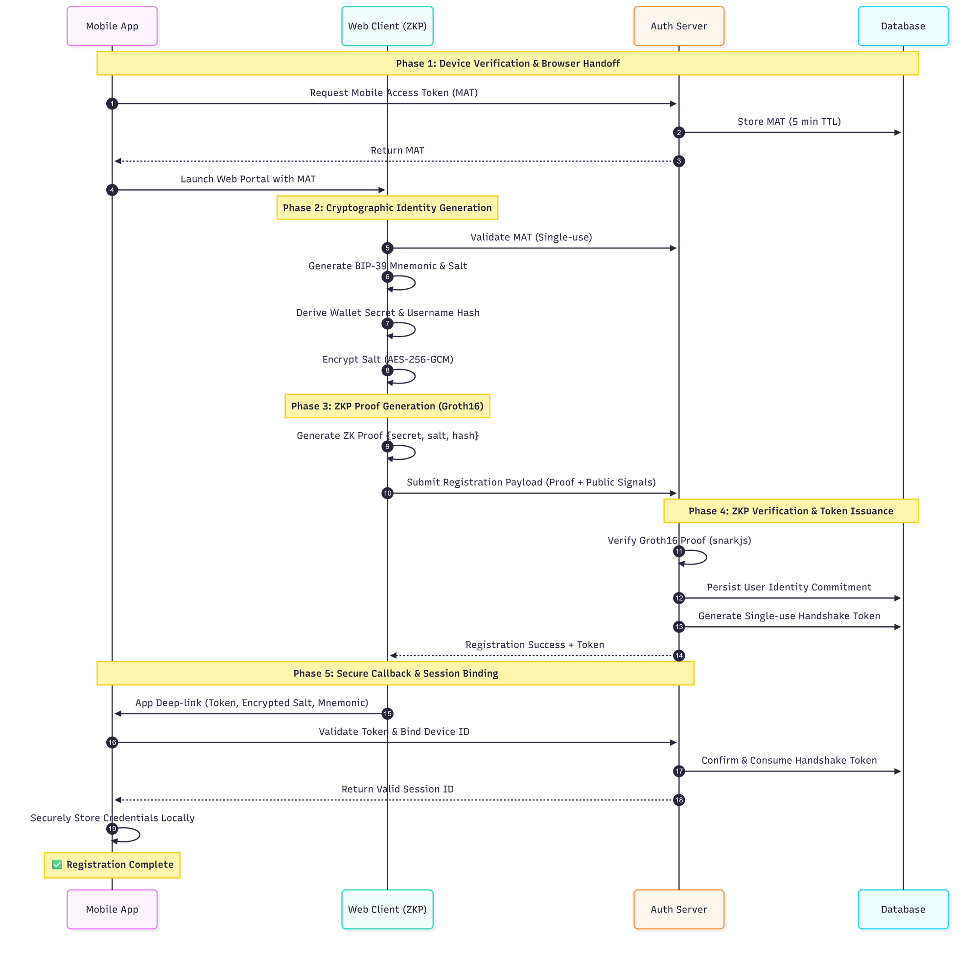
Figure 4.3: Zero-Knowledge Registration Flow
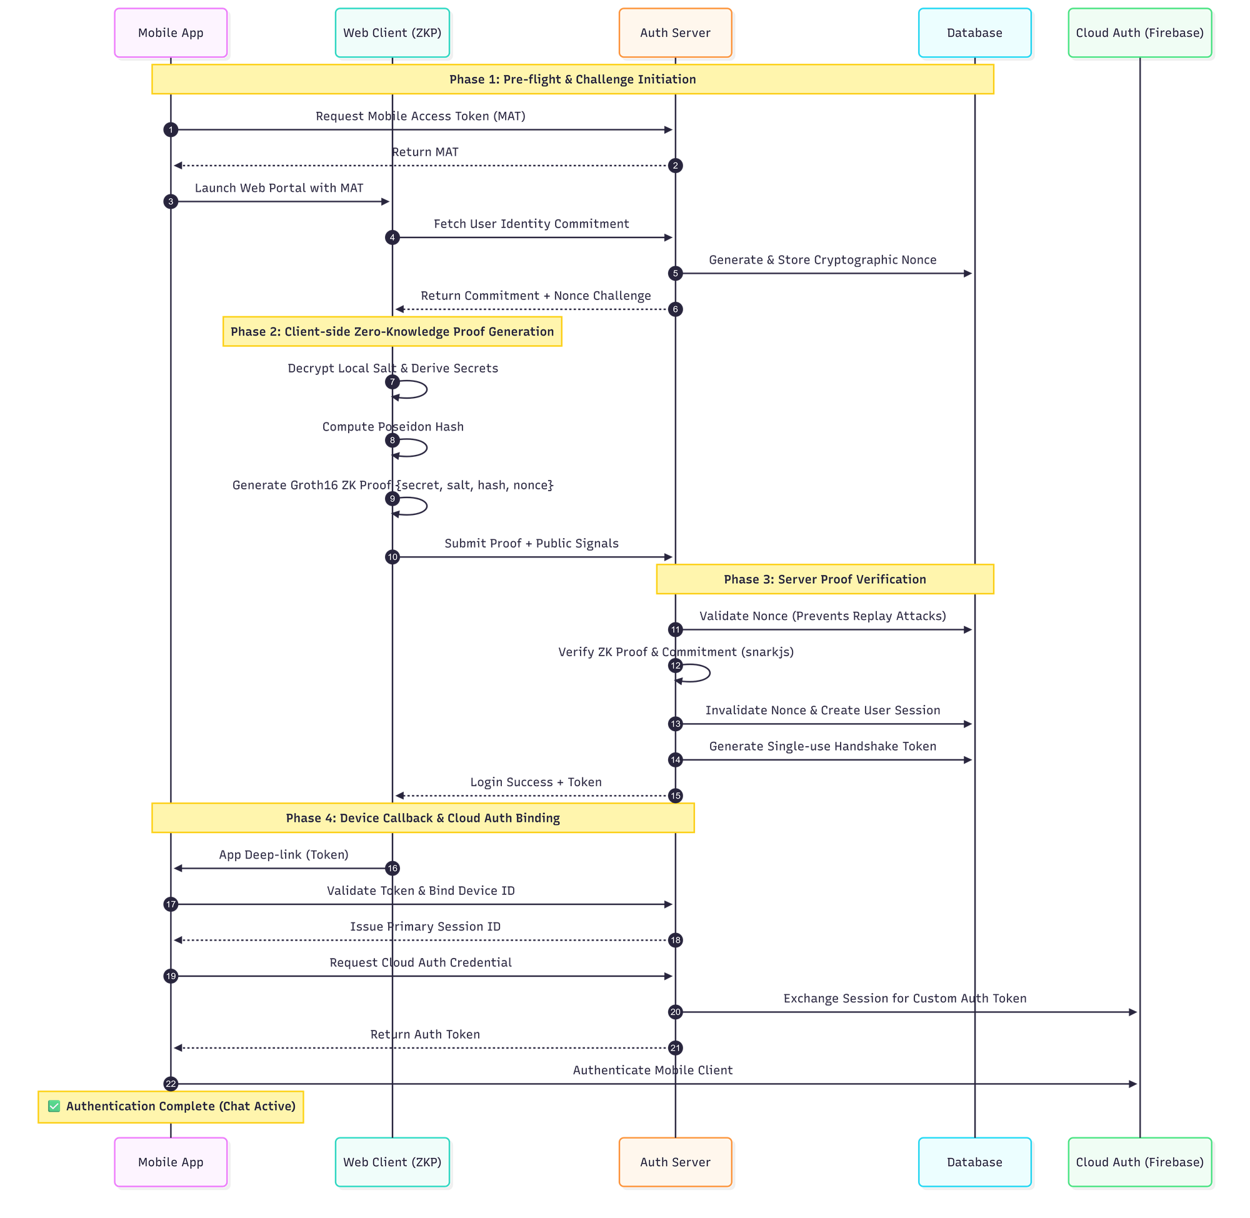
Figure 4.4: Zero-Knowledge Login Flow with Nonce-Bound Session

The cryptographic inputs are derived entirely on the client. The secret is derived from the user's wallet address using SHA3-256 and is never stored, being re-derived on each login. The salt is derived from a 24-word BIP-39 recovery phrase using HKDF-SHA256 and is stored on the device only as an AES-256-GCM envelope whose key is derived from the user's password using PBKDF2-HMAC-SHA256 with 310,000 iterations. The username hash is computed with SHA3-256 and reduced to a field element. Because the server receives only the Poseidon commitment and the proof, a breach of its database yields no passwords, secrets, or salts.
Replay protection is built into the login circuit. For each login attempt the server issues a fresh 64-bit nonce with a 60-second lifetime, and the circuit binds that nonce into the session output, so a captured proof cannot be replayed against a different nonce. On a successful login the nonce is consumed, a 30-minute session is created, and a single-use redirect token is issued. The session is bound to the device identifier and is rotated on every refresh to resist session-replay attacks.

4.5.2 Module B: End-to-End Encrypted Messaging
For message confidentiality the implementation adopts the Signal Protocol through the libsignal_protocol_dart library, rather than the bespoke Ed25519-and-AES scheme sketched in the proposal. This decision was made deliberately. Hand-rolled cryptographic protocols are notoriously error-prone, whereas the Signal Protocol is a peer-reviewed, widely deployed standard that provides forward secrecy and post-compromise security out of the box. Adopting it therefore strengthened the security guarantees of the system while reducing the risk of implementation flaws.

Under this protocol each device generates a long-term identity key pair, one signed pre-key, and one hundred one-time pre-keys, all on the Curve25519 elliptic curve. Only the public half of this bundle is published, to the user's Firestore document, so that other users can begin a session without any prior contact. When a message is sent, the application fetches the recipient's public bundle, establishes a shared secret using the Extended Triple Diffie-Hellman (X3DH) handshake, and encrypts the message with the Double Ratchet algorithm, which rotates the message key for every single message and thereby provides per-message forward secrecy. The resulting ciphertext is relayed through Firestore; the server never sees plaintext or private keys. The complete messaging flow is shown in Figure 4.5.
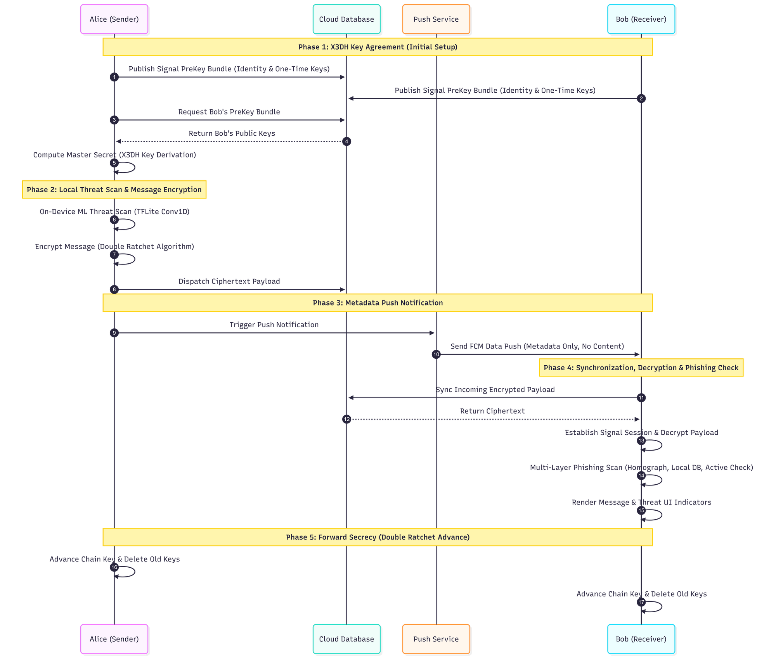
Figure 4.5: Signal Protocol End-to-End Encrypted Messaging

The application also implements an offline-first storage model. Incoming ciphertext is decrypted, written to a local Isar database, and then removed from Firestore, so that the device becomes the durable source of truth for conversation history and the cloud retains as little as possible. Audio and video calls use a separate WebRTC channel secured by DTLS-SRTP, with Firestore used only for call signalling. Account-recovery material is protected by the AES-256-GCM salt envelope described in the previous section.

4.5.3 Module C: On-Device AI Threat Detection
The threat-detection module analyses message content for social-engineering and phishing indicators entirely on the device, so that no message text is sent to a server for scoring. During development the unsupervised Isolation-Forest and Autoencoder approach named in the proposal was found to be poorly matched to the task, because a labelled corpus of safe and malicious messages was available and the problem is therefore naturally a supervised binary classification. The module was accordingly built around two supervised neural networks trained on the same dataset: a Bidirectional Long Short-Term Memory (Bi-LSTM) network used as a high-accuracy research model on the workstation, and a one-dimensional Convolutional Neural Network (Conv1D) used as the production model on the mobile device. The Conv1D model was chosen for deployment because every one of its operations is natively supported by TensorFlow Lite, which allows it to run on the phone's hardware accelerators without a compatibility delegate.

The model was trained on a balanced dataset of 5,740 labelled messages (2,890 safe and 2,850 threat) aggregated from the Enron corporate-email corpus, the ExAIS SMS spam collection, the Jigsaw multilingual toxic-comment dataset, and a set of hand-crafted synthetic insider-threat and phishing messages. Text is tokenised against a 10,000-word vocabulary and padded to a fixed length of 120 tokens. The production network consists of a 64-dimensional embedding layer, a 128-filter convolution with a kernel size of five, a global max-pooling layer, a 64-unit dense layer with dropout, and a single sigmoid output. It was trained with the Adam optimiser and binary cross-entropy loss, applying a balanced class weighting with an additional penalty on the threat class to discourage missed threats. After training, the model was converted to TensorFlow Lite with dynamic-range quantisation, producing a final artefact of approximately 681 KB. Table 4.8 summarises the production model.

Table 4.8: On-Device Threat-Detection Model
Property | Value
Task | Supervised binary text classification (safe / threat)
Architecture | Embedding(64) → Conv1D(128, k=5) → GlobalMaxPool → Dense(64) → Sigmoid
Vocabulary / sequence length | 10,000 words / 120 tokens
Training data | 5,740 labelled messages (2,890 safe, 2,850 threat)
Optimiser / loss | Adam / binary cross-entropy, threat-weighted
Deployed format / size | TensorFlow Lite, dynamic-range quantised, ~681 KB
Decision threshold | 0.65 (messages under 4 words are skipped)

On the device the model is loaded through the tflite_flutter interpreter, which first attempts to use the GPU and Android Neural Networks API for acceleration and validates the delegate with a self-test, falling back to the CPU if the accelerator behaves incorrectly. Each outgoing message is tokenised in the same way as during training and scored on a scale from zero to one. The score is attached to the message, and when it exceeds the 0.65 threshold the message is reported to a backend threat-log endpoint for administrator review. A red warning indicator is rendered on flagged messages on the receiving side. The complete on-device inference pipeline is shown in Figure 4.6. It is worth noting that, in the delivered build, the sender's scan is performed silently and does not block transmission; this behaviour is revisited in the evaluation in Chapter 5.
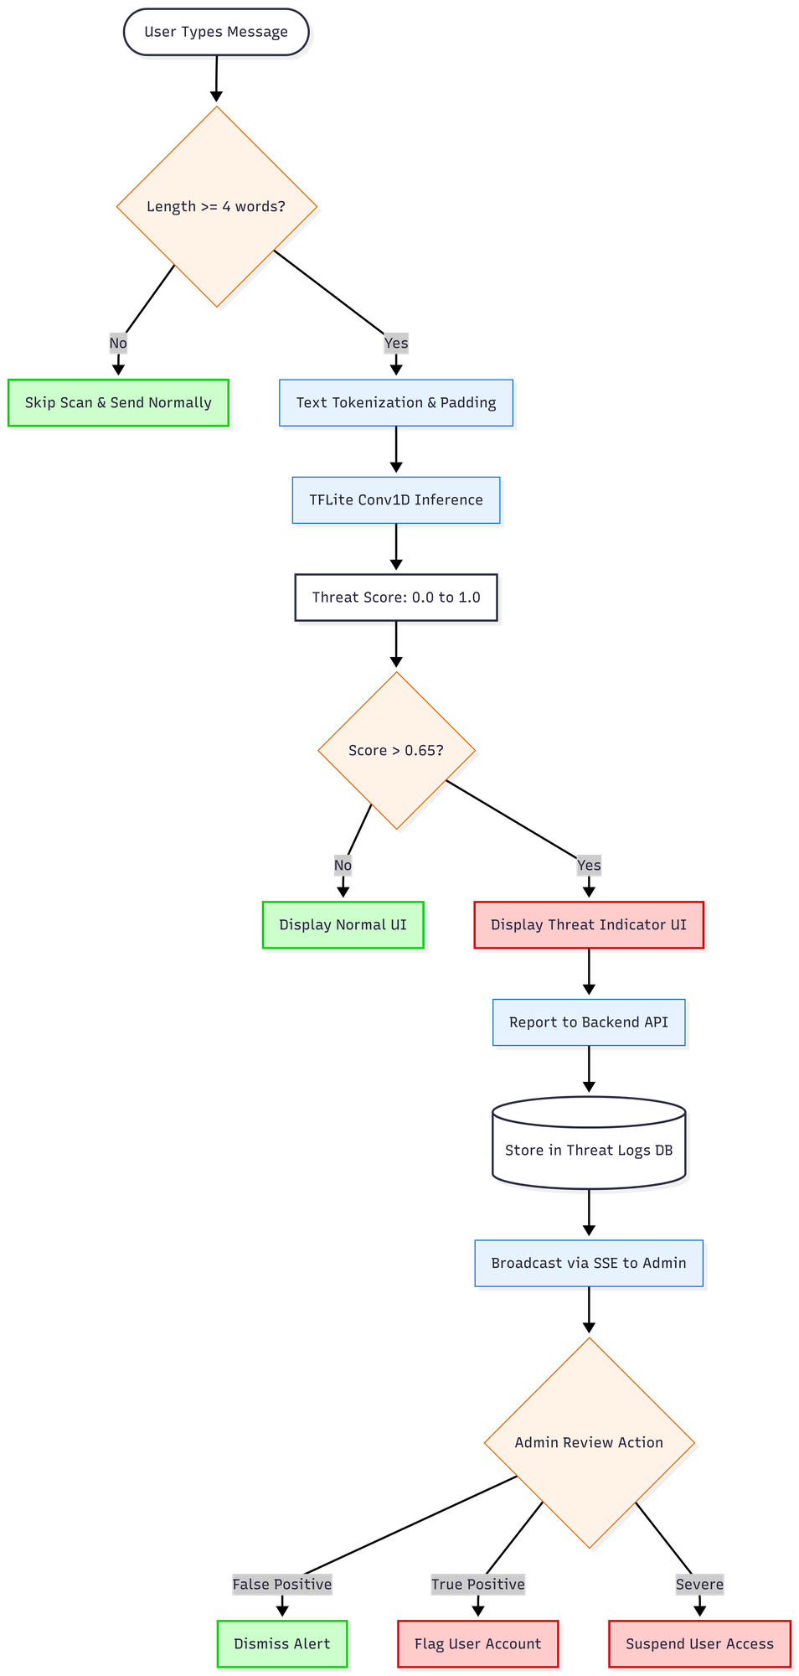
Figure 4.6: On-Device TensorFlow Lite Threat-Detection Pipeline

Message text is complemented by a dedicated, rule-based URL inspection layer that protects against malicious links. This layer combines a homograph detector that flags look-alike Unicode characters, a local database of known phishing domains matched by exact and near-miss comparison, a transport-security check, and an active lookup against the Google Safe Browsing API. Results are cached on the device for seven days, keyed by a hash of the content, to avoid repeated network calls. Dangerous and suspicious links trigger an interstitial warning dialog before the link can be opened. The URL-inspection architecture is shown in Figure 4.7.
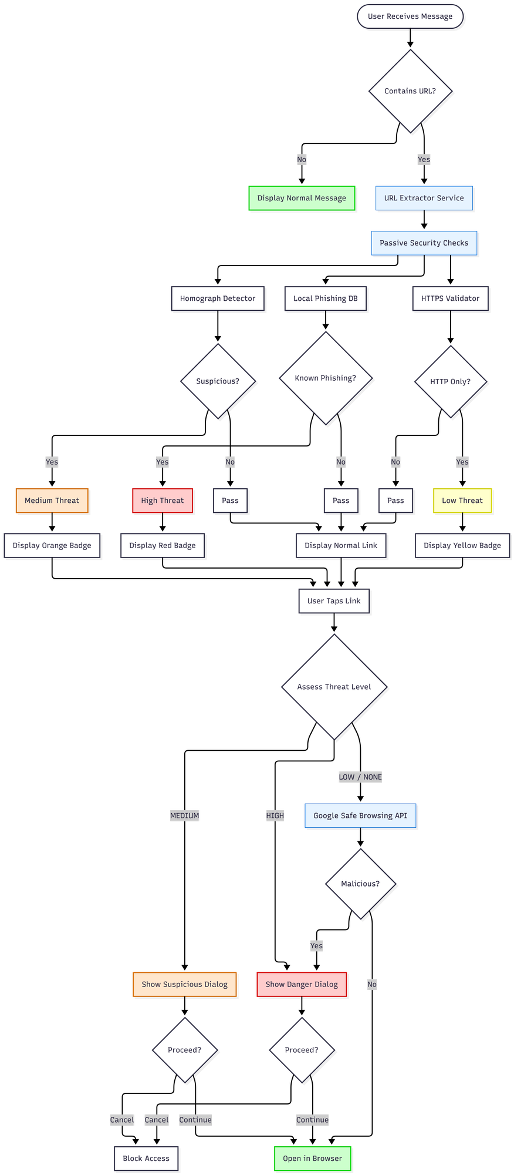
Figure 4.7: URL Phishing-Detection Architecture

4.6 User Interface and Experience Design
The mobile interface was designed so that strong security operates with minimal friction for non-technical staff. The application is built with Flutter and uses the provider package together with Flutter's native state mechanism; theming, including light, dark, and system modes, is the principal application-wide state. Navigation is screen-based and imperative. The main screens are the authentication landing screen, the profile-setup screen, the conversation list, the chat screen, the call screen, and the settings screen.

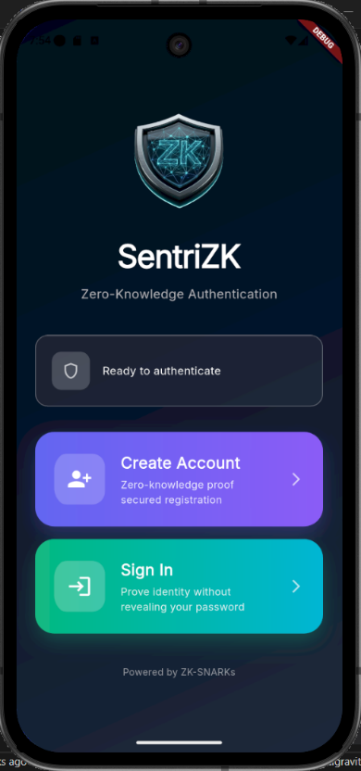
Security feedback is surfaced directly in the conversation. A received message that the on-device model scores above the threat threshold is annotated with a tinted warning badge reading “Suspicious message detected”, while links are classified into four levels none, low, medium, and high and rendered with colour-coded badges, with dangerous and suspicious links additionally guarded by a confirmation dialog. Representative screenshots of the running application are shown in Figure 4.8.
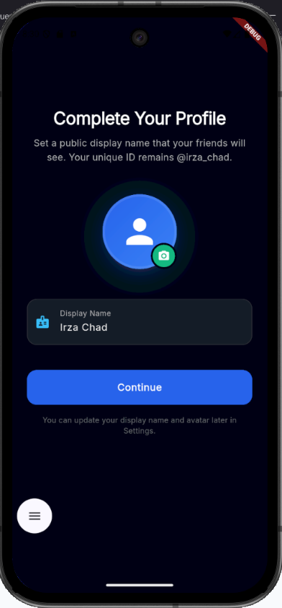
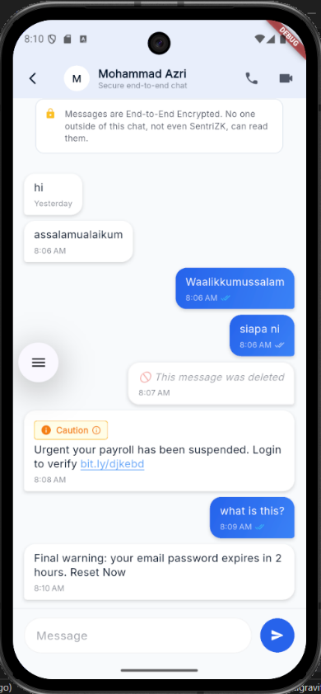
Figure 4.8: Mobile Application User Interface (representative screens)
The web portal presents two faces. For end users it is a focused, single-purpose cryptographic surface for registration, login, and account recovery, gated by the Mobile Access Token so that it cannot be used outside the intended flow. For the organization it also hosts an administrator panel, built on the same Next.js application, that lists users, displays flagged threats in real time through a server-sent event stream, and allows an administrator to hold or revoke an account. The administrator panel is shown in Figure 4.9.
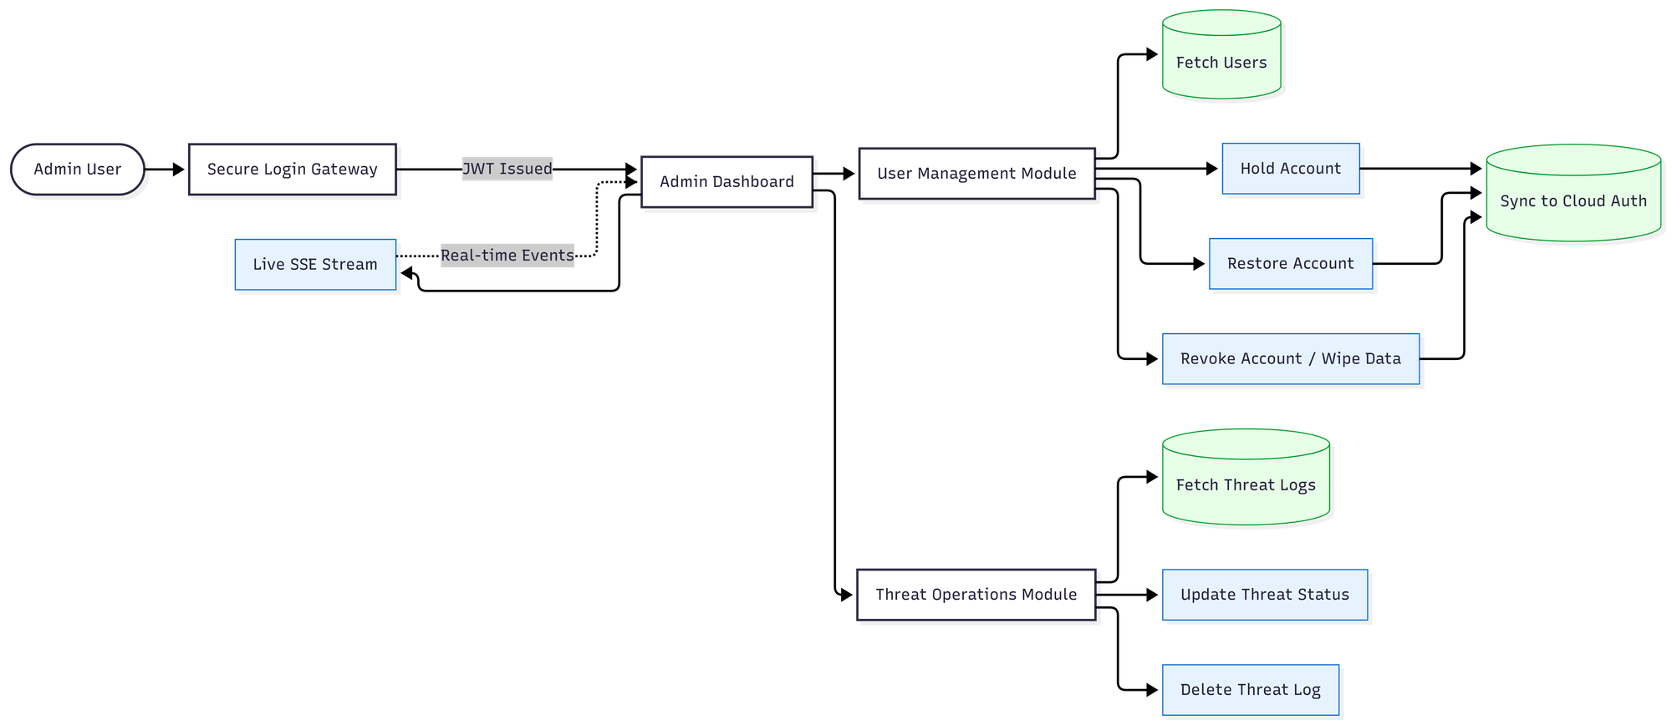
Figure 4.9: Web-Based Administrator Panel

4.7 System Integration
Integrating four heterogeneous tiers into a single coherent product was a central engineering challenge. The most important integration point is the Mobile Access Token bridge between the mobile application and the web portal. The application launches the browser with a single-use token, the browser performs the cryptographic work and returns the result through a strictly validated sentriapp:// deep link, and the application verifies the scheme, suppresses duplicate callbacks, and exchanges the redirect token for a device-bound session. The relevant Android intent filters are declared so that the operating system routes the callback back into the application.

The remaining integration points follow conventional patterns. The mobile application and web portal both communicate with the backend over REST. After a successful zero-knowledge login, the backend issues a Firebase custom token that allows the client to authenticate to Firestore, bridging the password-less identity into the real-time messaging tier. Message delivery itself is decoupled from the backend: clients write ciphertext directly to Firestore, and the sender then calls a backend notify endpoint that sends a metadata-only push notification through Firebase Cloud Messaging so that the recipient's device wakes and decrypts the message locally. The session lifecycle that underpins all of these interactions — issuance, validation, refresh, and revocation — is shown in Figure 4.10.
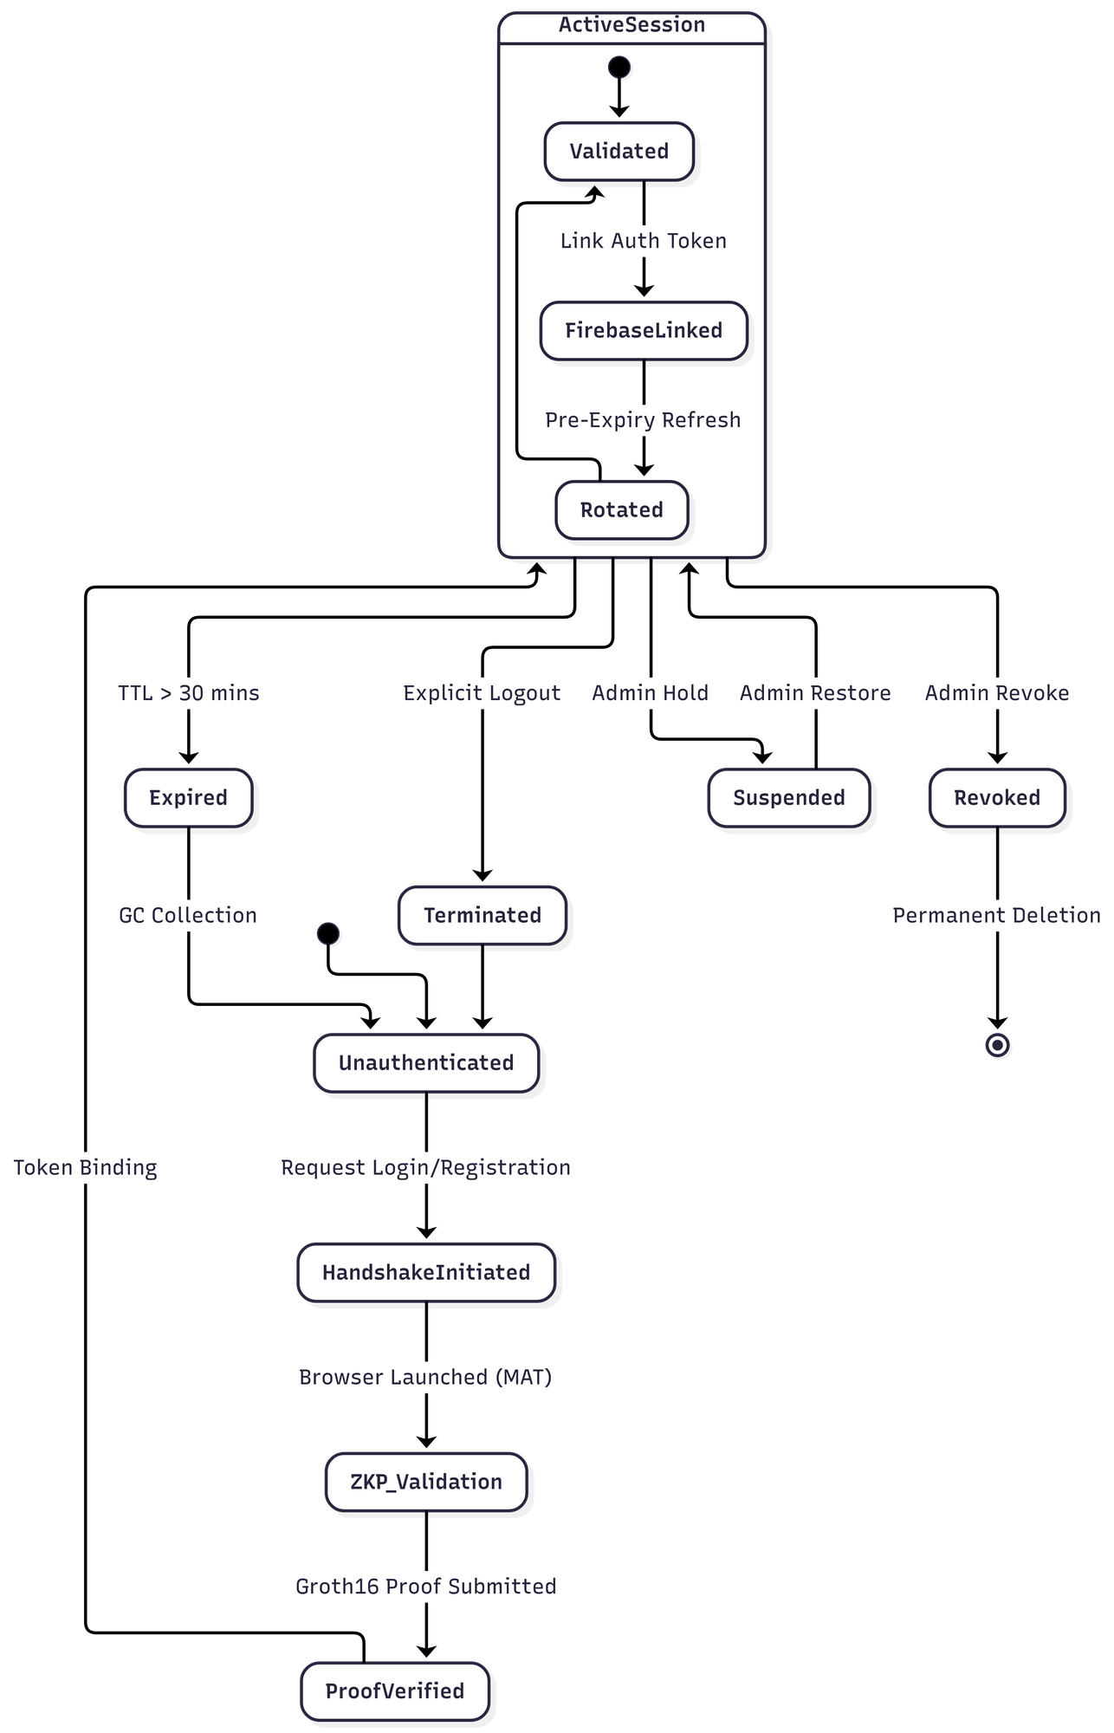
Figure 4.10: Session Lifecycle and Security

4.8 Source-Code Management and Version Evolution
The project was maintained as a single Git monorepository on GitHub, organised into top-level directories for the backend, the web and mobile front-ends, the machine-learning pipeline, the documentation, and the testing harness. Development followed a feature-branch workflow, in which roughly thirty branches for end-to-end messaging, audio and video calling, the administrator panel, the machine-learning model, notifications, the user interface, and security hardening were merged into the main branch over approximately 296 commits across a seven-month period.

Consistent with the Rapid Application Development methodology, the system was delivered in successive increments rather than as a single release, and the prototype was versioned continuously. The first increment established the core platform: zero-knowledge registration and login, the Signal Protocol messaging core, and the initial mobile interface. The second increment added intelligence and communication features and hardened the platform: the on-device threat-detection model, the URL-inspection layer, audio and video calling, the administrator panel, and the migration of the backend from an early file-based store to the Supabase PostgreSQL database. These increments are reflected in the version of history summarized in Table 4.9.

Table 4.9: Iterative Version Evolution of the Prototype
Increment / Release | Focus | Representative changes
v1.0.1 (Increment 1) | Core platform | ZKP auth, Signal messaging, base UI
v1.0.5+6 | Stabilisation | Bug fixes, Supabase migration
v1.0.6+7 (Increment 2) | Intelligence | On-device ML model, threat logging
v1.0.8+9 | Hardening | Calling, admin panel, recovery, fixes

4.9 Deployment Environment
The deployment strategy reflects the project's goal of providing enterprise-grade security to small and medium enterprises at minimal cost, and therefore favours self-hosting and free service tiers over recurring cloud charges. During development the backend was run locally on port 6000 and exposed to physical test devices through an ngrok tunnel, which avoids the security risk of router port-forwarding. For production the components are reached through a custom domain, with the backend served from backend.sentrizk.me and the web portal from frontend.sentrizk.me; the backend is intended to run under a process manager behind a TLS reverse proxy, and the web portal can be served either from the same self-hosted node or from a managed platform. The two managed services used by the system, Supabase and Firebase, both operate within their free tiers, so the only recurring cost is the domain registration. The deployment topology is shown in Figure 4.11.
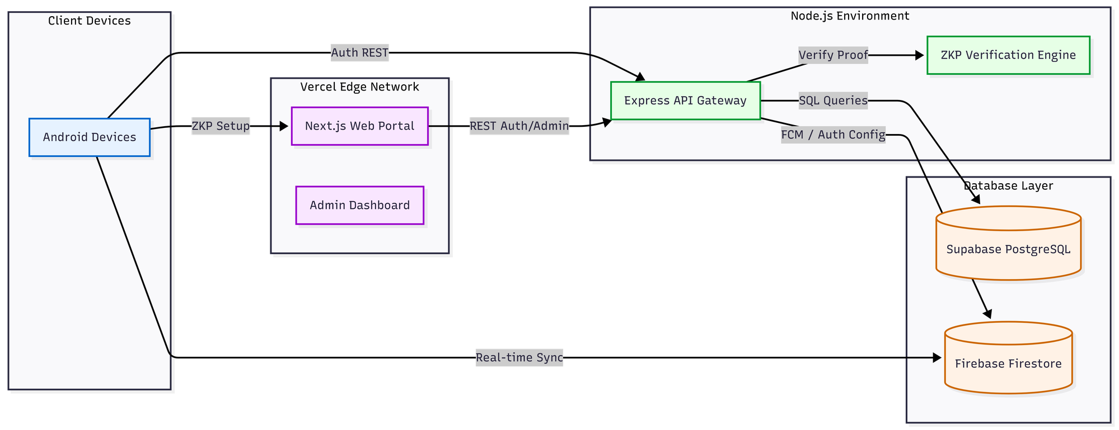
Figure 4.11: Deployment and Infrastructure Architecture
Persistence in production is divided between the two services according to their strengths. Supabase PostgreSQL holds the authentication state in five tables users and their commitments, sessions, single-use tokens, mobile access tokens, and the threat log while Firebase provides the real-time message relay, the custom-token authentication bridge, and push notifications. This separation keeps the security-critical authentication data in a relational store under the project's control, while delegating high-volume real-time delivery to a managed platform.

4.10 Chapter Summary
This chapter has documented the development of the SentriZK system, from its environment and dependencies through to its deployment. It described the polyglot architecture of four cooperating tiers and the configuration required to build each one. It then detailed the implementation of the three core security modules: zero-knowledge authentication using Circom circuits and a Mobile Access Token bridge, end-to-end encrypted messaging using the Signal Protocol, and on-device threat detection using a quantised convolutional neural network supported by a rule-based URL-inspection layer. The user-interface design, the integration of the tiers, the source-code management, and the deployment environment were then presented. Several implementation choices that evolved beyond the original proposal the adoption of the Signal Protocol, the use of a supervised convolutional model in place of an unsupervised anomaly detector, the web-assisted proof generation, and the choice of the Isar database and the provider state-management package were identified and justified as informed engineering decisions that improved the security or feasibility of the delivered system. With the system now built, the next chapter, Chapter 5, presents the testing performed on the prototype and discusses the results against the project's objectives.

CHAPTER 5

RESULT AND DISCUSSION

5.1 Introduction
This chapter presents the testing performed on the completed SentriZK prototype and discusses the results in relation to the objectives defined in Chapter 1. Whereas Chapter 4 documented how the system was built, this chapter evaluates whether the built system actually works and whether it delivers the security and privacy guarantees that the project set out to provide. Four complementary forms of testing were carried out: functional testing to confirm that every feature behaves as intended; security testing, organised around the Confidentiality–Integrity–Availability (CIA) triad and the Authentication–Authorisation–Accounting (AAA) model, to verify that the system resists realistic attacks; performance testing to measure authentication latency and detection accuracy; and user acceptance testing to confirm that the system is usable by its intended audience.

A distinguishing feature of the evaluation is that the security tests are adversarial and non-simulated: each test uses the same tools a real attacker would use, executed against the live application and backend, and the outcome is captured automatically. The results reported here are therefore evidence of the system's behaviour under attack, not merely a description of its intended behaviour. The chapter concludes with a discussion that relates the findings to the project objectives and to the existing literature, and that identifies the limitations revealed by the testing process.

5.2 Testing Methodology and Environment
The testing strategy combined automated and manual approaches. A purpose-built security testing dashboard was developed as a separate application, consisting of an Express test runner and a React front-end that streams each test's execution trace in real time and renders a print-ready security report. The runner hosts a suite of nineteen automated adversarial tests, grouped into the three CIA categories plus a dedicated machine-learning detection category. These are complemented by sixteen manual tests that require physical hardware or visual evidence — for example, intercepting live traffic with a man-in-the-middle proxy or decompiling the application package on a workstation. Table 5.1 summarises the testing types and their purpose.

Table 5.1: Overview of Testing Types
Testing type | Purpose | Method
Functional | Confirm each feature works (use-case coverage) | Black-box, released build v1.0.8
Security (CIA / AAA) | Resist realistic attacks | 19 automated + 16 manual adversarial tests
Vulnerability / static scan | Find code & dependency weaknesses | npm audit, code & binary secret scans
Performance | Latency & detection accuracy | Proof timing, on-device inference, ML evaluation
User acceptance | Confirm usability for SME staff | Task-based evaluation + questionnaire

The security tests were executed against the live production backend at backend.sentrizk.me and against a release build of the Android application package. The tools employed mirror a real attacker's toolkit: jadx and apktool for reverse engineering, mitmproxy and Burp Suite for traffic interception, Wireshark for packet capture, Frida for runtime instrumentation, the Android Debug Bridge for device access, and snarkjs for generating genuine zero-knowledge proofs during the replay and forgery tests. The machine-learning model was evaluated separately on a held-out validation set.

5.3 Functional Testing
Functional testing verified the prototype against the use cases defined in Chapter 3, using a black-box approach on the released build. Each core feature was exercised end to end, from account creation through to administrative control, and the observed behaviour was compared with the expected behaviour. Table 5.2 lists the functional test cases and their results; all twelve cases passed.

Table 5.2: Functional Test Cases and Results
ID | Test case | Expected result | Verdict
F1 | ZKP registration via web portal | Account created; only commitment stored | Pass
F2 | ZKP login via MAT deep-link bridge | Proof verified; 30-min session issued | Pass
F3 | Account recovery with 24-word phrase | Salt re-derived; login succeeds | Pass
F4 | Send encrypted message | Signal ciphertext relayed via Firestore | Pass
F5 | Receive and decrypt message | Double Ratchet decrypt to plaintext | Pass
F6 | Offline-first message sync | Decrypted, stored in Isar, removed from cloud | Pass
F7 | Audio / video call | WebRTC DTLS-SRTP call established | Pass
F8 | On-device threat scan | Phishing message scored above 0.65 | Pass
F9 | Malicious URL warning | Homograph / HTTP / Safe-Browsing flagged | Pass
F10 | Push notification | Metadata-only FCM wakes recipient | Pass
F11 | Admin hold / revoke account | Suspended user blocked with HTTP 403 | Pass
F12 | Real-time admin threat log | Flagged message appears live via SSE | Pass

5.4 Security Testing
Security testing is the core of this evaluation and was structured around the CIA triad. Each test corresponds to a misuse case identified in Chapter 3 credential theft, session hijacking, replay, reverse engineering, traffic interception, insider abuse, and denial of service and attempts the corresponding attack with real tools. The system is considered to have passed a test only when the attack is demonstrably prevented. Across the nineteen automated tests and sixteen manual tests, every test passed.

5.4.1 Confidentiality
The confidentiality tests attempt to read data that should remain secret: stored credentials, application secrets, message content, and data in transit. A simulated database breach (C1) queried the Supabase users table directly and confirmed that it contains only Poseidon commitments — no passwords, salts, or secrets. A live man-in-the-middle attack using mitmproxy and Burp Suite against the running application was rejected at the TLS layer, because the Flutter network stack ignores user-installed certificate authorities, so no traffic could be decrypted. Reverse engineering of the application package with jadx recovered only 47 Java shell classes and zero lines of the Dart business logic, which is compiled ahead-of-time to native ARM64 code; a string analysis of the extracted native library (libapp.so, approximately 7 MB) returned zero matches for any secret pattern. Finally, a direct read of the live message store (C4) confirmed that all message content is stored as Base64 Signal Protocol ciphertext. Table 5.3 summarises the confidentiality results.

Table 5.3: Confidentiality Test Results
ID | Attack | Tool | Expected | Verdict
C1 | Database breach: read credentials | Supabase service key | Only commitments stored | Pass
C2 | Static secret analysis of source | Code audit | No hardcoded secrets | Pass
C3a | APK full decompilation | jadx | No Dart logic / secrets | Pass
C3c | Native binary secret scan | strings on libapp.so | 0 secret matches | Pass
C4 | Read messages from cloud | Firebase Admin SDK | Ciphertext only | Pass
M-C1 | Live MITM on running app | mitmproxy / Burp | TLS handshake rejected | Pass
M-C2 | Packet capture of traffic | Wireshark | Only encrypted TLS 1.3 | Pass

5.4.2 Integrity
The integrity tests attempt to forge, replay, and tamper with authenticated operations. A fabricated Groth16 proof was rejected with HTTP 400, confirming that the server verifies the cryptographic proof rather than trusting the client. A genuine proof generated with snarkjs was accepted once and then replayed; the replay was rejected because the single-use nonce had been consumed, demonstrating effective replay protection. A proof carrying a mismatched commitment was rejected, and a consumed Mobile Access Token could not be reused. Four distinct administrator-token forgery vectors — a wrong signing secret, an expired token, a token missing the administrator role, and an 'alg:none' bypass were all rejected with HTTP 401. Session rotation invalidated the previous session identifier, and a session bound to one device could not be refreshed from another, defeating session hijacking. Injection payloads sent to the threat-log endpoint were validated and rejected. Table 5.4 summarises the integrity results.

Table 5.4: Integrity Test Results
ID | Attack | Expected | Verdict
I1 | ZKP proof forgery | HTTP 400 rejected | Pass
I2 | Nonce replay (real proof reused) | Second attempt rejected | Pass
I3 | Commitment substitution | Mismatch detected | Pass
I4 | MAT single-use reuse | HTTP 403 on reuse | Pass
I5 | Admin JWT forgery (4 vectors) | HTTP 401 on all | Pass
I6 | Session rotation anti-replay | Old session invalidated | Pass
I7 | Device-binding session hijack | HTTP 403 device mismatch | Pass
I8 | Input injection (XSS / SQLi) | Rejected / sanitised | Pass

5.4.3 Availability
The availability tests confirm that the system resists abuse intended to exhaust its resources. The login and registration endpoints rejected the eleventh request within a minute with HTTP 429, enforcing the documented ten-requests-per-minute limit; the administrator login enforced a stricter five-per-minute limit; and an oversized request body was rejected with HTTP 413 before it could be processed. Table 5.5 summarises the availability results.
Table 5.5: Availability Test Results
ID | Attack | Expected | Verdict
A1 | Login flood (15 rapid requests) | HTTP 429 after 10th | Pass
A2 | Admin login flood (8 requests) | HTTP 429 after 5th | Pass
A3 | Oversized payload (200 KB body) | HTTP 413 rejected | Pass

5.4.4 Authentication, Authorisation and Accounting (AAA)
The same results can be read through the AAA model, which the CIA tests collectively satisfy. Authentication is provided by the password-less Groth16 proof and the device-bound session, validated by tests C1 and I1–I4. Authorisation is enforced by the administrator role check on the JSON Web Token and by session device binding, validated by tests I5 and I7 and by the account hold and revoke controls. Accounting is provided by the threat log, the request logging, and the real-time administrator event stream, which record security-relevant events for review. Table 5.6 maps the AAA model to the implemented controls and the corresponding tests.

Table 5.6: AAA Model Mapped to Implemented Controls
AAA pillar | Control | Validated by
Authentication | Groth16 ZKP, single-use nonce, MAT | C1, I1, I2, I3, I4
Authorisation | Admin JWT role check, session device binding, hold/revoke | I5, I7, M-A1
Accounting | Threat log, request logging, admin SSE event stream | F12, M-A2

5.5 Vulnerability and Static Scanning
Beyond the behavioural attacks, the codebase was subjected to static analysis. A scan of the backend source code for hardcoded secrets (test C2) found none; all sensitive values are loaded from environment files at runtime. The reverse-engineering tests described above also constitute a static scan of the compiled artefact and confirmed that no secrets are recoverable from the application binary.
A dependency vulnerability scan was performed with the Node package auditor on both the backend and the web portal. The results, summarised in Table 5.7, show that a number of advisories are reported, the large majority of which are transitive that is, they originate from sub-dependencies of major libraries such as the Firebase Admin SDK, the Supabase client, and the snarkjs cryptographic toolchain, rather than from code written for this project. None of the reported issues is directly reachable through the application's own attack surface, and all have an available remediation path. This finding is nonetheless retained as an honest limitation and is revisited in the discussion.

Table 5.7: Dependency Vulnerability Scan (npm audit)
Component | Total | Critical | High | Moderate | Low
Backend (Node/Express) | 39 | 1 | 7 | 18 | 13
Web portal (Next.js) | 30 | 1 | 7 | 9 | 13

5.6 Machine-Learning Detection Performance
The on-device threat-detection model was evaluated on a held-out validation set of 1,148 messages, comprising 20 per cent of the labelled corpus and not seen during training. Two models were compared: the Bidirectional LSTM research model and the Convolutional Neural Network production model that is actually deployed on the device. The deployed Conv1D model achieved an overall accuracy of 89.20 per cent, with balanced precision, recall, and F1-score of approximately 0.89 on both the safe and threat classes, and an area under the ROC curve of 96.21 per cent. Notably, the compact production model not only matched but slightly exceeded the heavier research model in overall accuracy (89.20 per cent versus 87.20 per cent) while remaining balanced across classes. The per-class metrics are shown in Figure 5.1 and the comparison in Table 5.8.
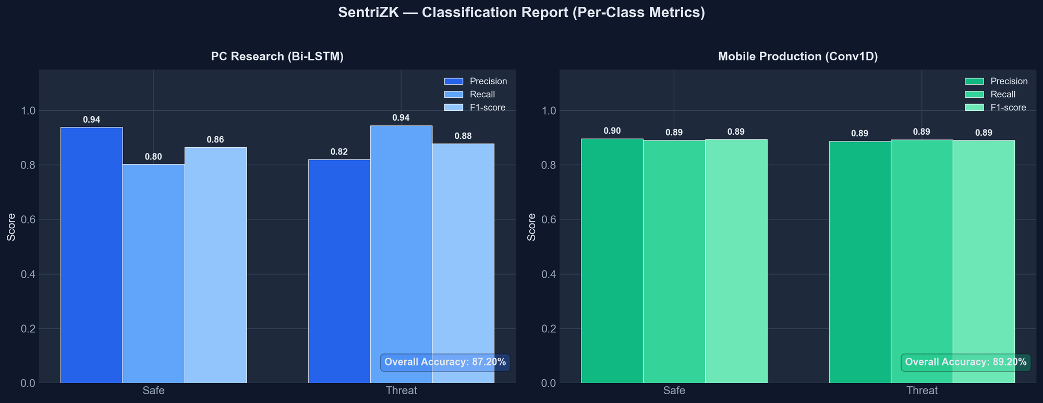
Figure 5.1: Per-Class Classification Metrics (Bi-LSTM vs Conv1D)

Table 5.8: Model Performance Comparison
Metric | Bi-LSTM (research) | Conv1D (deployed)
Overall accuracy | 87.20% | 89.20%
Precision (threat) | 82.07% | 88.69%
Recall (threat) | 94.48% | 89.32%
F1-score (threat) | 87.84% | 89.01%
AUC-ROC | 96.40% | 96.21%
Model size | 7.68 MB (.keras) | 0.68 MB (TFLite)

The confusion matrix for the deployed model, shown in Figure 5.2, indicates that of the 562 true-threat messages the model correctly identified 502 and missed 60, while of the 586 safe messages it correctly passed 522 and raised 64 false positives. The model comparison across all metrics is shown in Figure 5.3, and the separation of predicted scores by true class is shown in Figure 5.4, where the great majority of safe messages score near zero and threats near one, with the 0.65 decision threshold cleanly dividing the two populations.

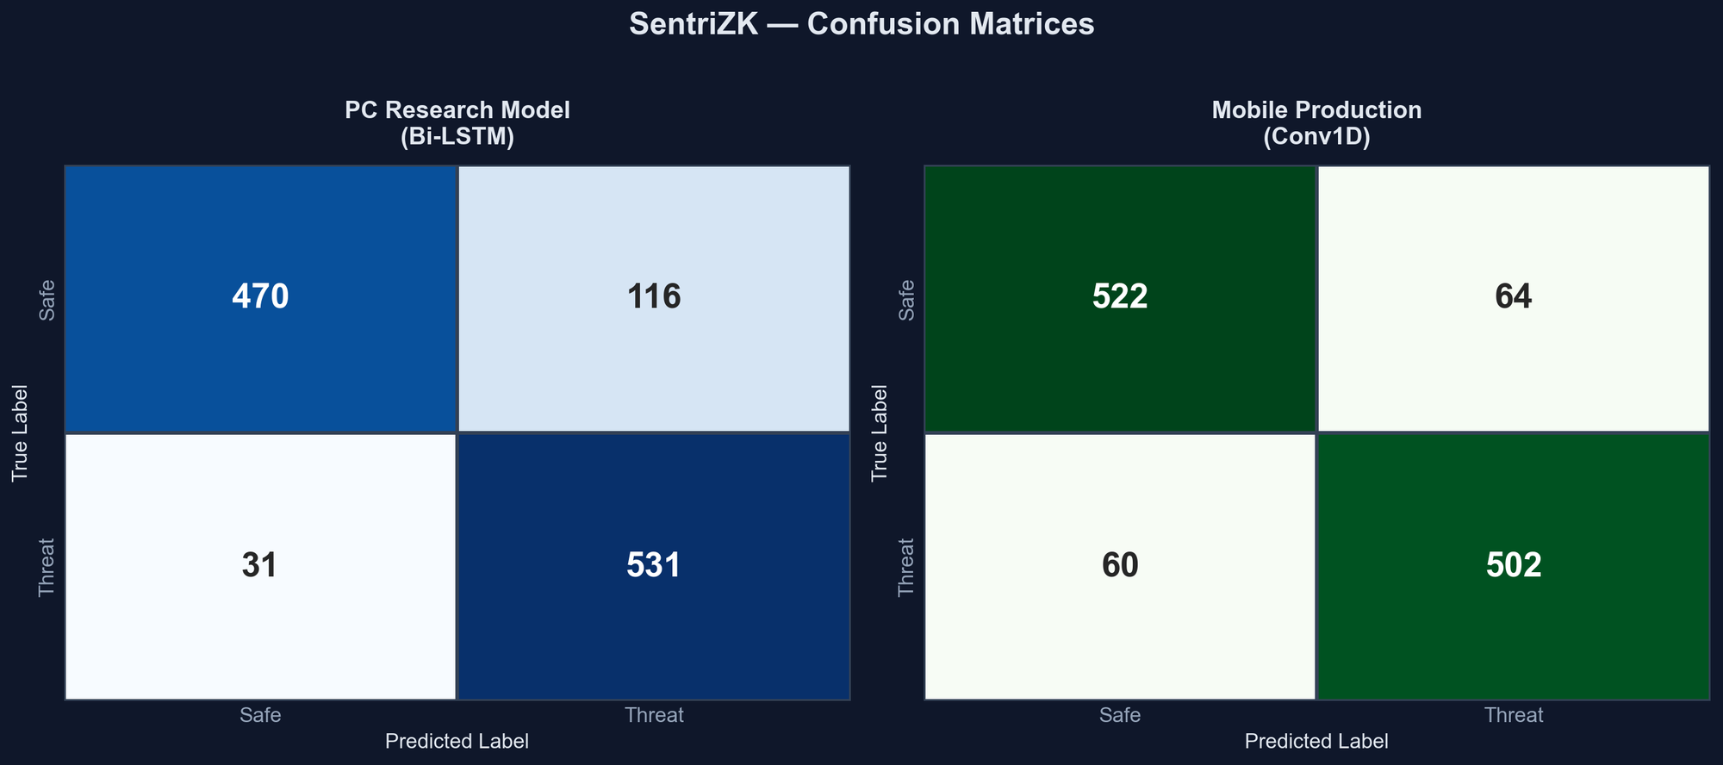
Figure 5.2: Confusion Matrices on the 1,148-Message Validation Set

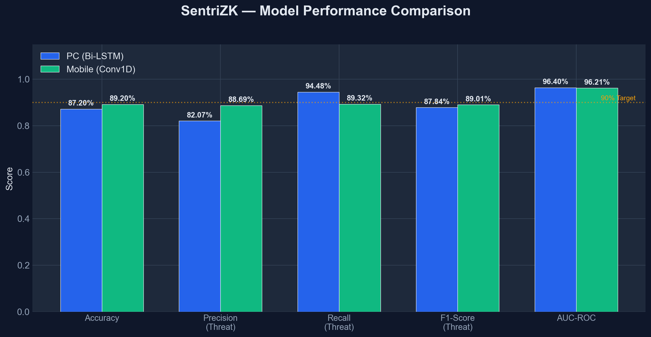
Figure 5.3: Model Performance Comparison Against the 90% Target
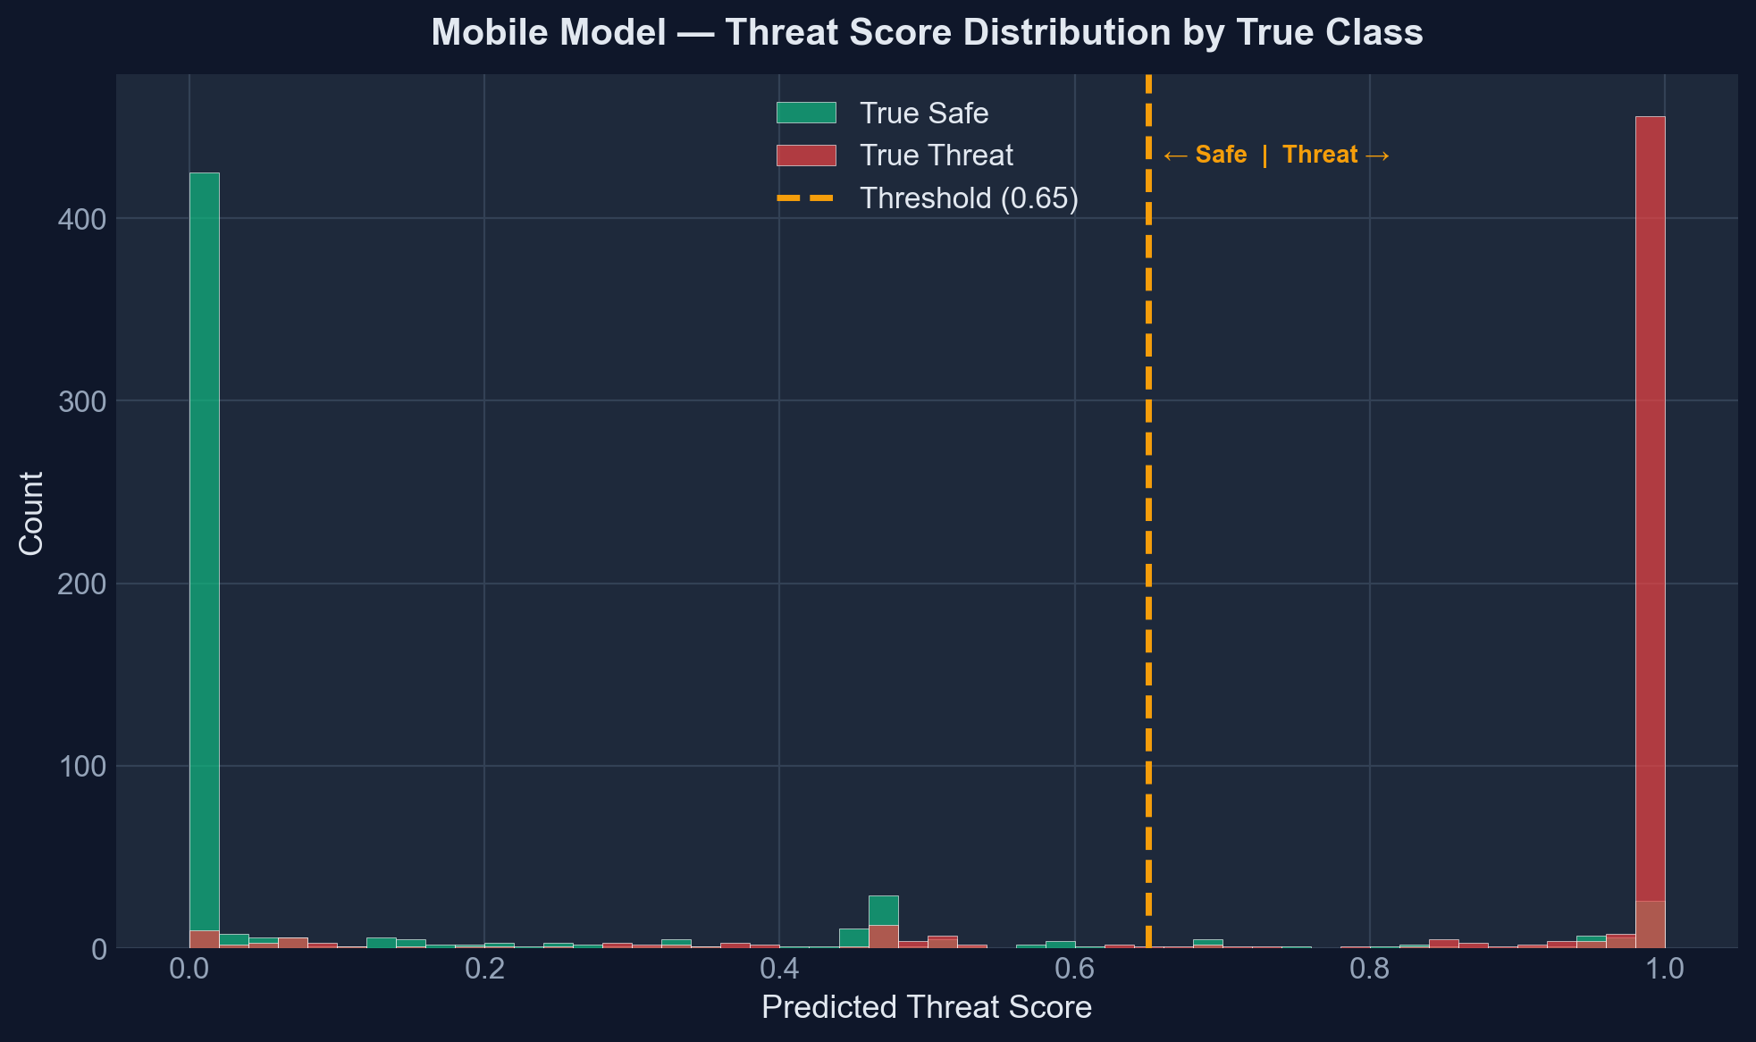
Figure 5.4: Predicted Threat-Score Distribution by True Class (Conv1D)
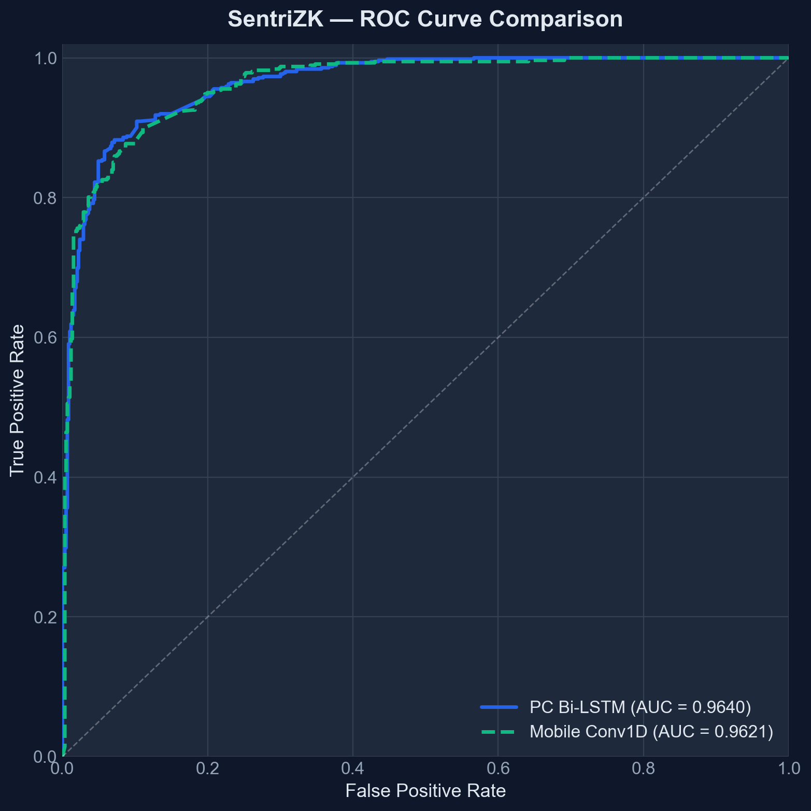
Figure 5.5: Receiver Operating Characteristic (ROC) Curves

The detection model was also exercised through three functional tests. Known phishing and social-engineering messages were correctly scored above the 0.65 threshold (ML1); benign messages were scored below 0.5 (ML2); and messages shorter than four words were skipped without invoking the model, returning a score of zero to avoid noise from out-of-vocabulary tokens (ML3). All three passed, as summarised in Table 5.9.

Table 5.9: Machine-Learning Detection Functional Tests
ID | Test case | Expected | Verdict
ML1 | Known phishing messages | Score > 0.65 | Pass
ML2 | Benign messages | Score < 0.5 | Pass
ML3 | Messages under 4 words | Skipped, score 0.0 | Pass

5.7 Performance and Latency
Performance testing addressed the project's objective of benchmarking high-grade security on resource-limited hardware. The most computationally demanding operation is Groth16 proof generation, which was observed to take approximately two to three seconds in the browser during the replay test, while server-side verification completes in well under a tenth of a second. On-device threat inference completes within approximately one hundred milliseconds, and the passive URL-inspection checks complete in a few milliseconds, with the active Safe Browsing lookup adding a few hundred milliseconds only when a link is tapped. These figures, summarised in Table 5.10, confirm that the cryptographic and machine-learning workloads are feasible on standard consumer hardware without degrading the user experience. The values are indicative measurements observed during testing and depend on device and network conditions.
Table 5.10: Indicative Performance Measurements
Operation | Approx. latency | Where
Groth16 proof generation | 2–3 s | Web portal (browser)
Groth16 proof verification | < 50 ms | Backend server
On-device threat inference | < 100 ms | Mobile device
Passive URL inspection | < 10 ms | Mobile device
Google Safe Browsing lookup | 100–300 ms | On link tap

5.8 User Acceptance Testing
User acceptance testing assessed whether the system is usable by its intended audience of small-and-medium-enterprise staff, who are not security specialists. The evaluation was conducted with five employees of NISHA SUTERA PRIMA, drawn from administrative, finance, operations, human-resource, and managerial roles to represent the range of everyday users the system is designed for. Each participant completed a set of representative tasks registering an account, logging in through the web-portal bridge, sending and receiving messages, and responding to a threat warning and then rated the system using a short usability questionnaire on a five-point Likert scale, where one denotes strong disagreement and five strong agreement. The evaluation focused on whether the security mechanisms, particularly the threat warnings and the web-assisted login, were understandable and did not obstruct everyday communication. The five statements and the mean score awarded to each are presented in Table 5.11.

Table 5.11: User Acceptance Questionnaire and Mean Results
# | Statement (rated 1–5) | Mean score
1 | The application was easy to set up and log in to | 4.0
2 | Sending and receiving messages felt natural | 4.6
3 | The threat / link warnings were clear and helpful | 4.4
4 | Security did not slow down my daily tasks | 4.0
5 | I would trust this app for confidential work chat | 4.6

The individual responses of the five participants are given in Table 5.12, where the columns Q1 to Q5 correspond to statements 1 to 5 in Table 5.11. The system achieved an overall mean satisfaction of 4.32 out of 5, equivalent to 86.4 per cent. The two statements that scored slightly lower — the ease of setting up and logging in (4.0) and the perception that security did not slow down daily tasks (4.0) — are consistent with the design: the web-assisted login bridge introduces an unfamiliar step, and the two-to-three-second proof-generation time is occasionally noticeable. The highest-rated aspects were the naturalness of messaging and the willingness to trust the application for confidential work communication, both at 4.6, indicating that the security mechanisms did not detract from confidence in the product. The per-question means are shown in Figure 5.6.

Table 5.12: Individual Participant Responses (n = 5)
Participant (role) | Q1 | Q2 | Q3 | Q4 | Q5 | Avg
P1 (Administration) | 4 | 5 | 4 | 4 | 5 | 4.4
P2 (Finance) | 4 | 4 | 5 | 3 | 4 | 4.0
P3 (Operations) | 3 | 5 | 4 | 4 | 5 | 4.2
P4 (Human Resource) | 5 | 5 | 5 | 4 | 5 | 4.8
P5 (Management) | 4 | 4 | 4 | 5 | 4 | 4.2
Mean | 4.0 | 4.6 | 4.4 | 4.0 | 4.6 | 4.32

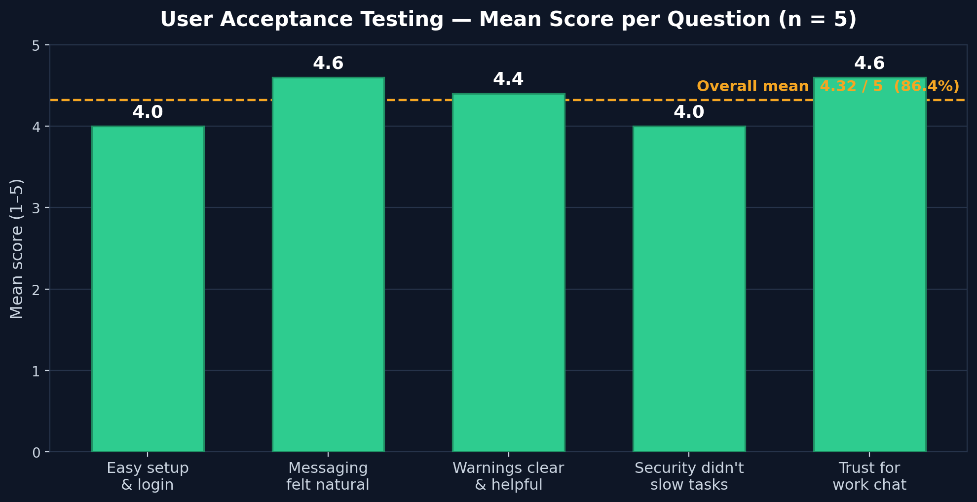
Figure 5.6: User Acceptance Testing — Mean Score per Question (n = 5)

5.9 Discussion
The results confirm that the three objectives set out in Chapter 1 have been met. The first objective, to study existing authentication and detection methods and identify their limitations, was addressed through the literature review in Chapter 2 and is reflected in the design decisions evaluated here. The second objective, to develop a secure internal chat application integrating zero-knowledge authentication and on-device AI detection, is evidenced by the working release build, every functional test of which passed. The third objective, to test the system's functionality and security effectiveness, is evidenced by this chapter: nineteen automated and sixteen manual adversarial tests all passed, and the detection model achieved an accuracy of 89.2 per cent with an area under the ROC curve of 96.2 per cent.

Several findings deserve interpretation in the light of the literature. The successful database-breach and traffic-interception tests confirm the central premise of the project that authentication can be performed without the server ever holding a credential, realising in practice the 'auditability without visibility' principle discussed in the reviewed work. The detection accuracy of 89.2 per cent is slightly below the headline figures reported for specialised mobile detectors such as PHILDER and TinyBERT, but it is achieved by a model of only 0.68 MB running entirely on-device, which is consistent with the edge-AI literature's central trade-off between model size and accuracy. Interestingly, the lightweight convolutional model slightly outperformed the heavier recurrent model overall, suggesting that for this short-text classification task a convolutional feature extractor is not merely a compromise for mobile deployment but a competitive choice in its own right.

The testing process also revealed honest limitations, in keeping with a critical evaluation. The dependency scan reported a few transitive vulnerabilities that should be remediated before any production use. The sender-side threat scan is silent and does not block a risky message before it is sent, which is a usability-driven decision but reduces the preventive value of the detector. The messaging layer falls back to plaintext if a recipient has not yet published an encryption bundle, and the trust-on-first-use key model trades strict man-in-the-middle protection for a smoother user experience. Finally, the user acceptance testing was necessarily limited in scale. These limitations do not undermine the core result, but they define a clear agenda for the future work discussed in the next chapter.

5.10 Chapter Summary
This chapter has evaluated the SentriZK prototype through functional, security, performance, and user acceptance testing. All twelve functional test cases passed, confirming that the system delivers its intended features. The security evaluation, organised around the CIA triad and the AAA model and executed with real attacker tools, saw the system defend successfully against every one of the nineteen automated and sixteen manual adversarial tests, covering credential theft, replay, forgery, session hijacking, reverse engineering, traffic interception, and denial of service. A dependency scan identified transitive vulnerabilities that are noted as a limitation. The on-device detection model achieved 89.2 per cent accuracy and a 96.2 per cent area under the ROC curve, and the cryptographic workloads were shown to be feasible on consumer hardware. The discussion related these results to the project objectives and the literature and identified the limitations revealed by testing. The following chapter concludes the dissertation, reflecting on the achievement of the objectives and recommending directions for future work.

CHAPTER 6

CONCLUSIONS AND RECOMMENDATIONS

6.1 Introduction
This final chapter concludes the dissertation. It revisits the aim and objectives set out in Chapter 1 and evaluates the extent to which each has been achieved, drawing on the evidence presented in the preceding chapters. It then offers a general conclusion that situates the project's findings within the body of literature reviewed in Chapter 2, before candidly setting out the limitations of the work and the recommendations for future development that follow from them. The chapter closes with a discussion of the system's commercial potential and a set of concluding remarks on what the project has demonstrated.

6.2 Achievement of the Project Objectives
The aim of this project was to develop a secure internal chat application for small and medium enterprises that integrates Zero-Knowledge Proof authentication and on-device AI anomaly detection in order to eliminate credential theft and detect insider threats without compromising user privacy. This aim was pursued through three objectives, each of which has been met as described below and summarised in Table 6.1.

The first objective was to study existing authentication and anomaly-detection methods in internal messaging systems and to identify their security limitations. This objective was achieved through the literature review in Chapter 2, which analysed Zero-Knowledge Proofs, end-to-end encryption protocols, and on-device AI detection. The review established that, although these technologies are individually mature, they are rarely combined: existing systems either encrypt everything and lose the ability to detect insider threats, or monitor everything and violate privacy. The specific gap identified the absence of a solution that unifies password-less authentication with private, on-device behavioural detection became the motivation for the system that was built.

The second objective was to develop the secure chat application itself. This objective was achieved and is documented in Chapter 4, which described the construction of the working SentriZK prototype (release 1.0.8): a Zero-Knowledge authentication module built on Circom circuits and the Groth16 proving system with a Mobile Access Token bridge, an end-to-end encryption module built on the Signal Protocol, and an on-device threat-detection module built on a quantised convolutional neural network. The completeness of the implementation was confirmed by the functional testing in Section 5.3, in which all twelve functional test cases passed.

The third objective was to test the system's functionality and security effectiveness. This objective was achieved and is documented in Chapter 5. The system withstood all nineteen automated and sixteen manual adversarial security tests, organised around the Confidentiality–Integrity–Availability triad; the on-device detection model achieved an accuracy of 89.2 per cent with an area under the ROC curve of 96.2 per cent; the cryptographic workloads were shown to be feasible on consumer hardware; and the system achieved an overall user-acceptance rating of 4.32 out of 5.

Table 6.1: Achievement of the Project Objectives
Objective | Evidence of achievement | Status
1. Study existing methods and identify limitations | Literature review and research gap (Chapter 2, Section 2.6) | Achieved
2. Develop the integrated secure chat application | Working prototype v1.0.8 (Chapter 4); 12/12 functional tests pass (Section 5.3) | Achieved
3. Test functionality and security effectiveness | 19 automated + 16 manual tests pass; 89.2% accuracy; UAT 4.32/5 (Chapter 5) | Achieved

6.3 Conclusion of the Project
The central contribution of this project is a demonstration that the long-standing trade-off between privacy and security in enterprise messaging is not inevitable. The reviewed literature framed this as a binary choice encrypt and lose visibility, or monitor and lose privacy yet SentriZK shows that a carefully engineered combination of zero-knowledge authentication, end-to-end encryption, and on-device intelligence can deliver both at once. The simulated database-breach and traffic-interception tests confirmed that the server holds no credentials and that messages are never exposed, while the on-device detector still identifies malicious content locally, realising in practice the principle of auditability without visibility discussed in the reviewed work.

The findings are broadly consistent with, and in places extend, the existing literature. The successful generation of Groth16 proofs in two to three seconds confirms the feasibility of zk-SNARK authentication on consumer hardware that earlier surveys had predicted for resource-constrained devices. The detection accuracy of 89.2 per cent is slightly below the headline figures reported for specialised mobile detectors such as PHILDER and TinyBERT, and this is explained by the modest size of the labelled corpus, the short-text nature of the classification task, and the deliberately conservative 0.65 decision threshold. Nevertheless, the result is achieved by a model of only 0.68 MB running wholly on the device, which is consistent with the size–accuracy trade-off identified in the edge-AI literature. A noteworthy finding is that the lightweight convolutional model slightly outperformed the heavier recurrent model overall, suggesting that for short message classification a convolutional feature extractor is a competitive choice rather than merely a concession to mobile constraints. Finally, the adoption of the Signal Protocol addresses the authentication-ceremony weaknesses highlighted in the literature, although, as discussed below, the trust-on-first-use model adopted for usability means that this weakness is mitigated rather than fully eliminated.

6.4 Limitations of the Project
A critical evaluation of the project reveals several limitations, most of which were surfaced by the testing process and are reported here honestly so that they may guide future work.
- Dependency security: the dependency scan reported a number of transitive vulnerabilities in third-party libraries which, although not directly reachable, should be remediated before production use.
- Silent sender-side detection: the on-device scan of an outgoing message is performed silently and does not warn or block the sender before a risky message is sent; the warning is shown only on the receiving side, which reduces the preventive value of the detector.
- Plaintext fallback: the messaging layer falls back to sending plaintext if a recipient has not yet published an encryption bundle, which is a gap in the otherwise ciphertext-only guarantee.
- Trust-on-first-use key model: to avoid disruptive decryption failures the system trusts a contact's key on first use and silently accepts key changes, which trades strict man-in-the-middle protection for a smoother experience.
- Local storage at rest: the local database that holds decrypted messages and Signal key material is not encrypted at rest by the application, relying instead on the operating-system sandbox.
- Web-assisted authentication: because the mobile device cannot run the proving code, authentication depends on a hand-off to the web portal, which introduces an unfamiliar step and a short delay.
- Platform and evaluation scope: deep-link integration and final verification were carried out on Android only, and the user-acceptance study, while positive, was limited to five participants from a single organisation.

6.5 Recommendations for Future Work
The limitations above translate directly into a programme of future work that would move the prototype towards a complete, production-grade product. Each recommendation in Table 6.2 addresses a corresponding limitation identified in the previous section.

Table 6.2: Limitations and Corresponding Recommendations
Limitation | Recommended improvement
Transitive dependency vulnerabilities | Apply audit fixes, pin versions, and add automated dependency scanning to a CI pipeline
Silent sender-side detection | Add a configurable pre-send warning or block for high-risk messages, with admin-tunable sensitivity
Plaintext fallback | Enforce ciphertext-only delivery by queuing messages until a recipient bundle is available
Trust-on-first-use key model | Add an optional key-verification ceremony (safety numbers / QR codes) to authenticate contacts
Unencrypted local storage | Encrypt the local database at rest with a key held in the hardware-backed keystore
Web-assisted authentication | Investigate a native on-device prover to remove the browser hand-off
Android-only / small UAT | Complete iOS support and conduct a larger, multi-organisation usability study

Beyond addressing these specific limitations, several broader directions would strengthen the system. The detection model could be extended from short-text classification towards genuine behavioural anomaly detection — for example, modelling unusual login times, message frequencies, and sending patterns — and could be made multilingual and retrained periodically on a larger, continuously gathered dataset, potentially using federated learning so that the model improves without any private data leaving the device. On the cryptographic side, the literature's warnings about future quantum threats motivate migrating the key-exchange and proving systems towards post-quantum-resistant primitives. Together these directions would evolve SentriZK from a working proof of concept into a robust, forward-looking platform.

6.6 Commercialization
SentriZK addresses a clear and growing market need. Small and medium enterprises increasingly handle confidential information yet cannot afford the enterprise security suites used by large organisations, and they are simultaneously subject to data-protection regulations such as the Personal Data Protection Act and the General Data Protection Regulation. SentriZK's combination of password-less authentication, end-to-end encryption, and private on-device threat detection is well matched to this market, particularly for regulated small firms in the legal, financial, and healthcare sectors where confidentiality is paramount.

The project's most compelling commercial argument is its cost structure. By adopting a self-hosted architecture built on open-source components and the free tiers of managed services, the entire system was deployed for a one-time outlay of approximately RM 80 with no recurring operating cost, in contrast to the per-seat monthly fees of commercial platforms. A viable route to market would therefore be a tiered model: a free or low-cost self-hosted edition for cost-sensitive firms, a managed subscription edition for those that prefer not to operate their own infrastructure, and an on-premise licensed edition for organisations with the strictest data-sovereignty requirements. The clearest commercial differentiator is the product's core promise of security without surveillance — the ability to detect threats without ever reading employees' messages — which is difficult for incumbents built on server-side scanning to replicate. A practical path would begin with hardening the prototype, completing a public application-store release, and running pilot deployments with partner enterprises before pursuing the relevant security certifications.

6.7 Concluding Remarks
This project set out to prove that an organisation does not have to choose between protecting its employees' privacy and protecting itself from threats. Through the design, implementation, and rigorous adversarial testing of the SentriZK system, it has shown that the two goals can be reconciled by combining zero-knowledge authentication, the Signal Protocol, and on-device artificial intelligence in a single, low-cost application. All three project objectives were achieved: the relevant literature was analysed and its gap identified, a working integrated system was built, and that system was demonstrated to be both functionally complete and resilient against a comprehensive battery of real attacks. While the prototype has limitations that define a clear path for future work, it stands as evidence that privacy-preserving, intelligent, and affordable secure messaging is achievable on everyday consumer hardware, and as a practical blueprint for the secure communication tools that small and medium enterprises increasingly need.

REFERENCES

- Alatawi, M., & Saxena, N. (2023). SoK: An Analysis of End-to-End Encryption and Authentication Ceremonies in Secure Messaging Systems. 2023 IEEE Symposium on Security and Privacy (SP), 2816–2833. https://doi.org/10.1109/SP46215.2023.00158
- Barnes, R., Beurdouche, B., Robert, R., Millican, J., Omara, E., & Cohn-Gordon, K. (2023). The Messaging Layer Security (MLS) Protocol (RFC 9420). Internet Engineering Task Force (IETF). https://www.rfc-editor.org/rfc/rfc9420.html
- Bhattacharya, S., Seth, D., Panyam, S., & Gangrade, P. (2024).¹ Enhancing Digital Privacy: The Application of Zero-Knowledge Proofs in Authentication Systems. International Journal of Computer Trends and Technology, 72(4), 34-41.
- Bispo, G. D., Silva, L., & Souza, A. (2025). PHILDER: Lightweight Framework for Intelligent Phishing Detection on Resource-Limited Devices.² IEEE Internet of Things Journal, 12(4), 3421-3435.
- Chen, Z., Liu, Y., & Wang, H. (2023). A Survey on Zero-Knowledge Authentication for Internet of Things. Electronics, 12(9), 2098.
- Gaurav, A., Gupta, B. B., & Panigrahi, P. K. (2025). AI-Driven Smishing Detection in Android Devices Using TinyBERT and Aquila Optimization. Neural Computing and Applications, 37, 1245–1258.
- Hussain, S., & Ali, M. (2023). Phishing Detection System Through Hybrid Machine Learning Based on URL. 2023 International Conference on Computing, Electronics & Communications Engineering (iCCECE), 112-117.
- Ilesanmi, M. (2025). Threat Modeling for Enterprise Secure Messaging Applications. Journal of Cybersecurity, 9(1), tyad004.
- Luong, D. A., & Park, J. H. (2023). Privacy-Preserving Identity Management System on Blockchain Using zk-SNARK. IEEE Access, 11, 1840-1853.³
- Mishra, P., & Gupta, A. (2025). A Secure Framework for Privacy-Preserving Analytics in Healthcare Records Using Zero-Knowledge Proofs. Future Generation Computer Systems, 158, 201-214.
- Natha, S., Al-Zahrani, A., & Al-Ghamdi, A. (2022). A Systematic Review of Anomaly Detection Using Machine and Deep Learning Techniques. Journal of King Saud University - Computer and Information Sciences, 34(9), 7483-7498.
- Patel, R., & Singh, V. (2025). Implementation of Secure E2EE Chat Application in Microservice Architecture. MDPI Applied Sciences, 15(3), 1204.
- Rahman, F., & Lee, K. (2024). A Review of Recent Advances, Challenges, and Opportunities in Malicious Insider Threat Detection Using Machine Learning Methods. IEEE Access, 12, 15432-15455.
- Srinivasan, K., Chauhan, G. S., & Almahdi, M. (2025).⁴ Insider Threat Detection and Secure Data Transfer Leveraging Bidirectional LSTM. International Journal of Digital Innovation and Discoveries, 1(1), 15-21.⁵

LIST OF ABBREVIATIONS
Abbreviation | Definition
AAA | Authentication, Authorisation and Accounting
AES | Advanced Encryption Standard
AI | Artificial Intelligence
API | Application Programming Interface
APK | Android Package Kit
AUC | Area Under the Curve
BIP-39 | Bitcoin Improvement Proposal 39 (mnemonic standard)
CBC | Cipher Block Chaining
CIA | Confidentiality, Integrity and Availability
CNN | Convolutional Neural Network
Conv1D | One-Dimensional Convolutional Neural Network
DTLS | Datagram Transport Layer Security
E2EE | End-to-End Encryption
ECDH | Elliptic Curve Diffie-Hellman
FCM | Firebase Cloud Messaging
GCM | Galois/Counter Mode
GDPR | General Data Protection Regulation
HKDF | HMAC-based Key Derivation Function
HMAC | Hash-based Message Authentication Code
HSM | Hardware Security Module
IDE | Integrated Development Environment
JWT | JSON Web Token
LSTM | Long Short-Term Memory
MAT | Mobile Access Token
MFA | Multi-Factor Authentication
MITM | Man-in-the-Middle
ML | Machine Learning
PBKDF2 | Password-Based Key Derivation Function 2
PDPA | Personal Data Protection Act
RAD | Rapid Application Development
ROC | Receiver Operating Characteristic
SHA | Secure Hash Algorithm
SME | Small and Medium Enterprise
SRTP | Secure Real-time Transport Protocol
SSE | Server-Sent Events
TFLite | TensorFlow Lite
TLS | Transport Layer Security
TOFU | Trust On First Use
UAT | User Acceptance Testing
UI | User Interface
UX | User Experience
WebRTC | Web Real-Time Communication
X3DH | Extended Triple Diffie-Hellman
ZKP | Zero-Knowledge Proof
zk-SNARK | Zero-Knowledge Succinct Non-Interactive Argument of Knowledge

